A Level P.E. L6

**Curriculum Intent**

Students will study the theoretical aspects of Physical Education, which will enable them to:

* Develop knowledge and understanding of the factors that underpin physical activity and sport and use this knowledge to improve performance
* Understand how the physiological and psychological states affects performance
* Understand the key socio-cultural factors that influence people’s involvement in physical activity and sport
* Understand the contribution which physical activity makes to health and fitness
* Understand the role of technology in physical activity and sport

Students will also take part in practical activities, which will enable them to:

* Refine their ability to perform effectively in physical activity and sport by developing skills and techniques and selecting and using tactics, strategies and compositional ideas
* Develop their ability to analyse and evaluate to improve performance

*Intelligence and skill can only function at the peak of their capacity when the body is healthy and strong - John F Kennedy*

Physiological factors affecting performance (30% of total A Level)

* Joints, movements and muscles
* Functional roles of muscles and types of contraction
* Analysis of movement
* Skeletal muscle contraction
* Muscle contraction during exercises of differing intensities/ during recovery
* Cardiovascular system at rest
* Cardiovascular system during exercise of differing intensities/during recovery
* Respiratory system at rest
* Respiratory system during exercise of differing intensities/during recovery
* Diet and nutrition
* Ergogenic aids
* Aerobic training, strength training, flexibility training, periodisation of training, impact of training on lifestyle diseases
* Biomechanical principles
* Levers
* Analysing movement through use of technology

Psychological factors affecting performance (20% of total A Level)

* Classification of skills
* Types and methods of practice
* Transfer of skills
* Principles and theories of learning movement skills
* Stages of learning
* Types and uses of guidance/ Types and uses of feedback
* Memory models
* Individual differences – personality, attitudes, motivation, arousal, anxiety, aggression, social facilitation, group and team dynamics in sport

Social-Cultural issues in physical activity and sport (20% of total A Level)

* Emergence and evolution of modern sport:
* How social and cultural factors shaped the characteristics of, and participation in, sports and pastimes in pre-industrial Britain
* How contemporary factors are shaping the characteristics of, and participation in, sport in the 21st century
* Global Sporting Events:
* The modern Olympic Games
* Hosting global sporting events

Performance or coaching (15% of total A Level)

* 1 activity from the approved list of available sports, completed as coursework

Evaluation and Analysis of Performance for Improvement (15% of total A Level)

* Observing a performance and providing an oral response analysing and critically evaluating it by drawing upon the knowledge, understanding and skills a learner has learnt throughout the course, completed as coursework

**Key Concepts:**

Across the two years, students will study a range of topics under the headings of: Applied anatomy and physiology, exercise physiology, biomechanics, skill acquisition, sports psychology and sport and society.

In Lower 6th, students will study the skeletal system and muscular system, the cardiovascular and respiratory system, diet and nutrition, preparation and training methods, Newton’s laws of motion, force and the use of technology, stability and the lever systems, classification of skill, types and methods of practice, transfer of skills, learning theories, stages of learning, guidance and feedback, individual differences, group and team dynamics and goal setting in sport, emergence and evolution of modern sport, sport in the twenty first century, global sporting events.

In Upper 6th, students will study energy for exercise, recovery, altitude and heat, injury and the rehabilitation of injury, linear and angular motion, fluid mechanics and projectile motion, memory models, attribution in sport, confidence and self-efficacy, leadership, stress management to optimise performance, ethics and deviance in sport, commercialisation and media, routes to sporting excellence in the UK, modern technology in sport.

**Students will learn:**

Matriculation Requirements:

**To achieve a 6 or above in GCSE PE**

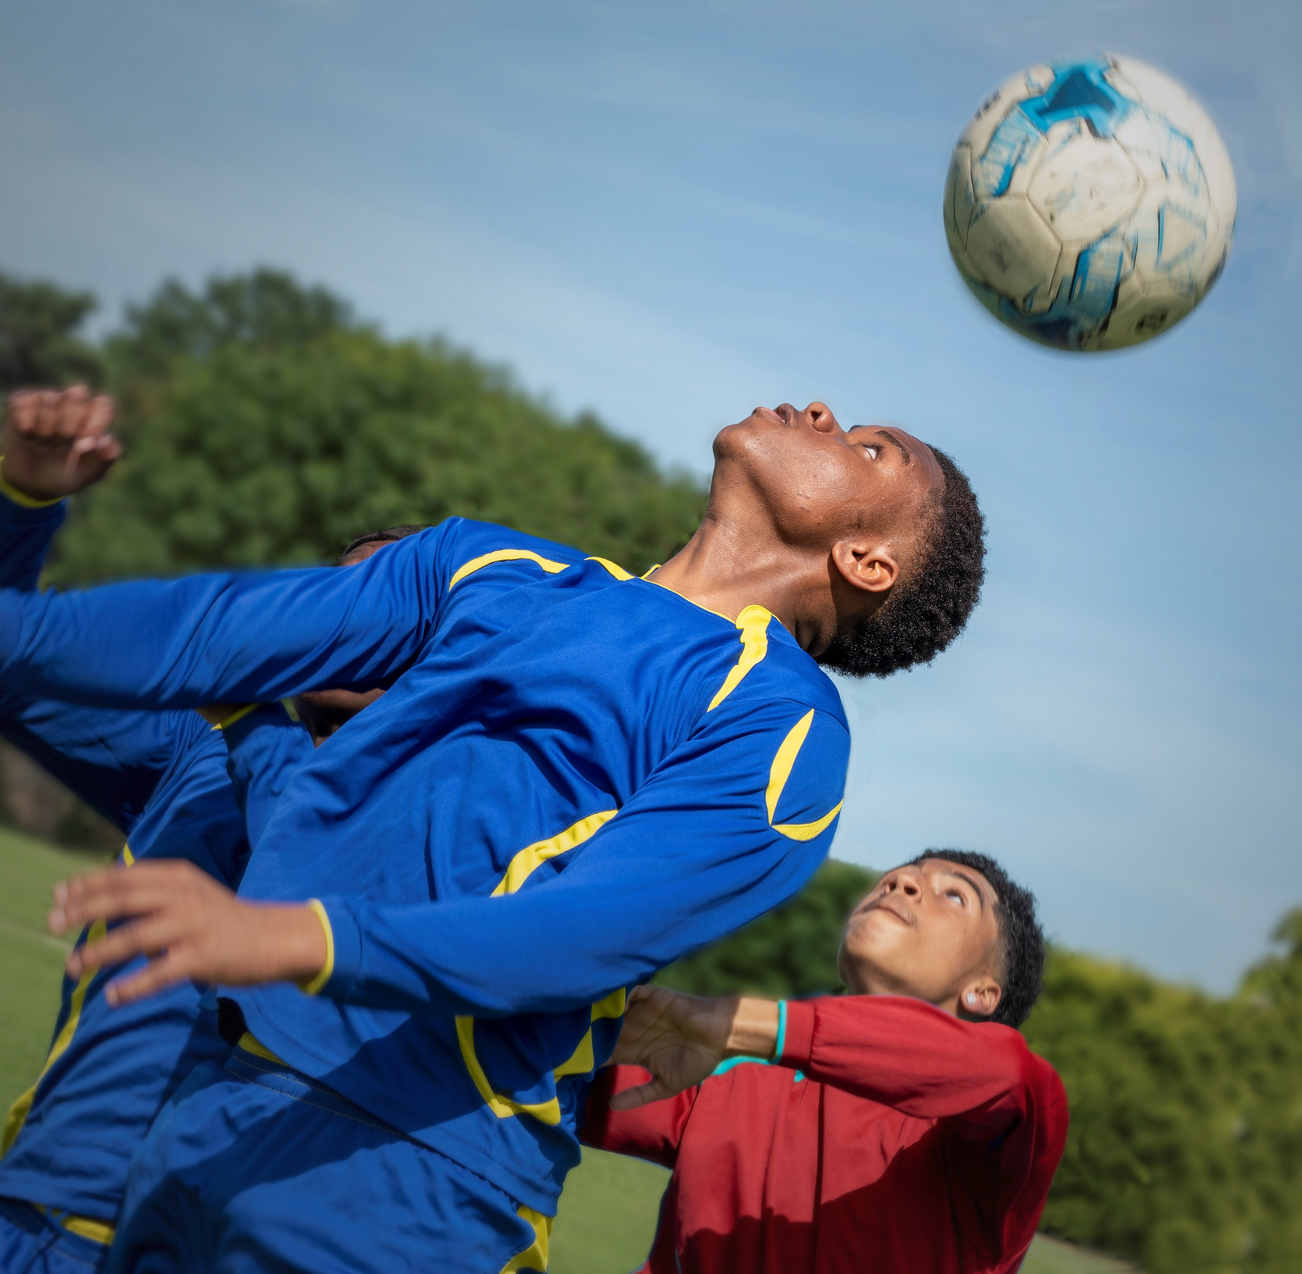

**What does excellence look like?**

Demonstrate, apply, analyse and evaluate knowledge and understanding of the factors that underpin performance and involvement in physical activity and sport

Ability to accurately describe and explain concepts in appropriate detail

The ability to fully analyse the concepts studied, using practical examples to show how theoretical concepts can be applied

Use of specialist vocabulary in the appropriate context

Use of quantitative skills with interpretation and analysis of data

Use of definitions, equations, formulae and units of measurement

The ability to evaluate the positives and negatives of different concepts

Ability to critically evaluate theories, thinking and science

Ability to detail the evolution of modern sport and evaluate the impact of a range of factors upon participation in sport

Evaluate the influence of concepts such as globalisation and commercialisation and the media in developing 21C sport

Demonstrate skills and techniques in physical activity and sport

Analyse and evaluate performance

**How can you enhance your learning at home?** **Wider reading and extra challenge:**

Physiological Factors affecting performance

[www.visiblebody.com](http://www.visiblebody.com)

[www.ptdirect.com](http://www.ptdirect.com)

[www.verywellfit.com](http://www.verywellfit.com)

Psychological Factors affecting performance

[www.teachpe.com](http://www.teachpe.com)

[www.sports-training-adviser.com](http://www.sports-training-adviser.com)

[www.simplypsychology.org](http://www.simplypsychology.org)

[www.believeperform.com](http://www.believeperform.com)

Social-cultural issues in physical activity and sport

<https://www.youtube.com/watch?v=Ze5f5P_tQL8>

<https://www.youtube.com/user/r2fteachpe/videos?disable_polymer=1>

<https://www.youtube.com/watch?v=baX-TcGqY9c>

Text Box

**Internationalism**

* International exchange programme providing opportunities to explore sport within different cultures
* Community lectures series
* International Day sporting events

**Within the curriculum**

* Global sporting events and comparison of these and theories in sport
* Extensive use of international examples in team performance, examining the influence of cultural factors
* Analysis of global sporting events and the influence of concepts such as globalisation and commercialism

**How will we assess impact?**

Our teaching will encourage the development and refinement of key evaluative and analytical skills; acquiring knowledge, developing an argument, extended writing, evaluating theories and evidencing them with real world examples.

These skills are assessed regularly in accordance with the departmental assessment cycle across all three units.

They will be assessed predominately through timed assessments, linear knowledge tests, classroom discussion and end of year PPEs.

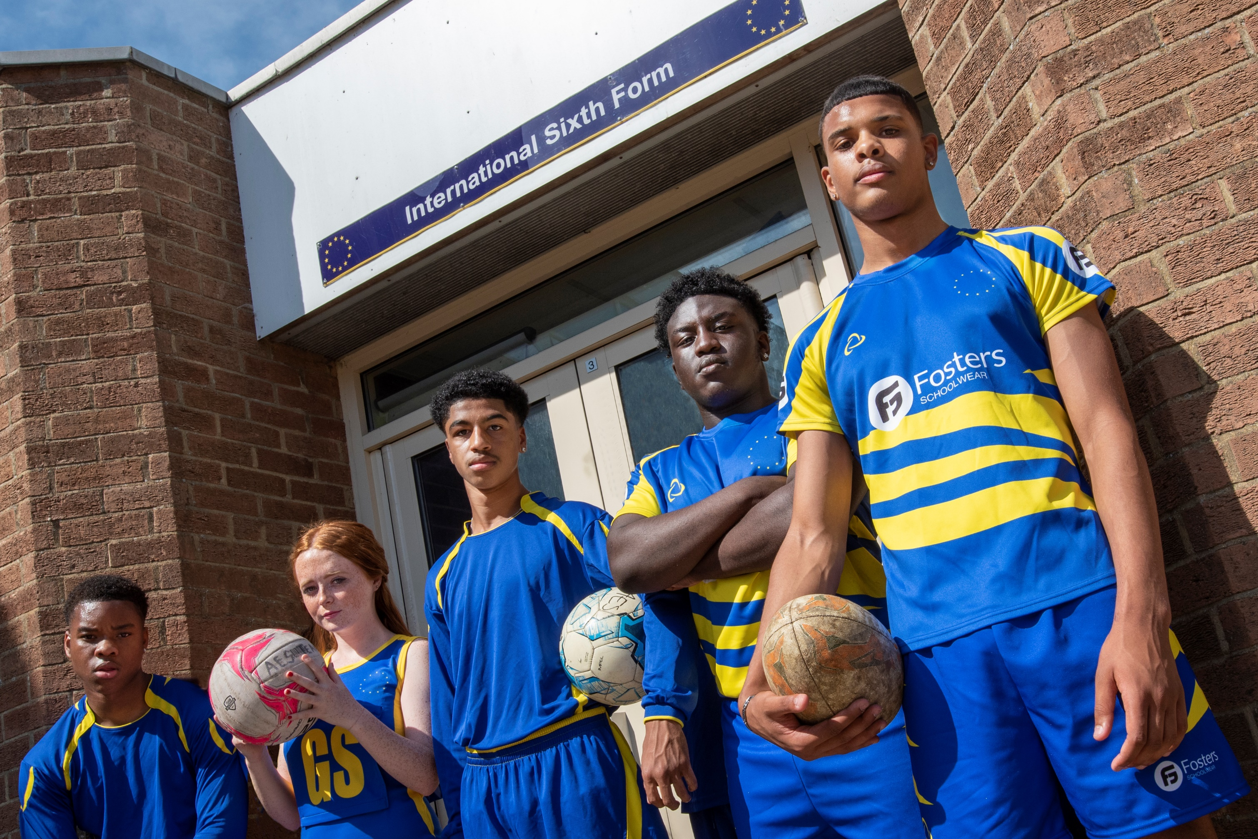

*“I don't believe that you should ever replace physical education. Even in a thousand years, a computer will never be able to do so.”*

***Sal Khan***

**Extra Challenge:**