A Level Sociology

**Curriculum Intent**

Our ambition is to instil a love of Sociology in our students encouraging self-confidence and high aspirations. We will make them challenge their understanding of the world and develop a critical and reflective approach to understanding contemporary society that reflects the mission statement of the school. Our students will ask big questions about social issues and in doing so they will develop their sociological imagination, challenging taken for granted assumptions. Our curriculum is diverse covering attractive and engaging topic options that inspire students to learn. Students progress from the study of research methods used by sociologists and theories developed into synoptic analysis of key social institutions: Education; Families and Households; The Media and Crime and Deviance. These topics promote understanding of culture and socialisation and stratification in society as well as awareness of social inequalities, prejudice and discrimination.

*“The function of sociology, as of every science, is to reveal that which is hidden”* **Pierre Bourdieu**

*Read more:*[*https://www.wiseoldsayings.com/sociology-quotes/#ixzz6Sm6CVNJG*](https://www.wiseoldsayings.com/sociology-quotes/#ixzz6Sm6CVNJG)

Our curriculum is diverse covering attractive and engaging topic options that inspire students to learn. Students progress from the study of research methods used by sociologists and theories developed into synoptic analysis of key social institutions. Topics are taught as follows:

Paper 1

Education with Theory and Methods

Paper 2

Topics in Sociology – Families and Households and The Media

Paper 3

Crime and Deviance with Theory and Methods

**Why study this subject?**

Studying A-Level Sociology offers valuable insights into the complexities of human society. It enables to students to understand the structures, institutions and dynamics of society as well as social issues and inequalities. A-Level Sociology facilitates personal growth by encouraging self-awareness and empathy.

**Students will learn:**

**How can learning be enriched at home?**

Students are encouraged to explore the wide variety of online resources listed that complement the course.

[www.revisesociology.com](http://www.revisesociology.com/)

<https://theconversation.com/uk>

<https://www.aljazeera.com/aboutus/>

<https://www.theweek.co.uk/>

<https://baumaninstitute.leeds.ac.uk/this-is-not-an-obituary/>

[www.s-cool.com](http://www.s-cool.com/)

<https://www.bbc.co.uk/programmes/b006qy05>

<https://www.ted.com/talks?topics%5B%5D=sociology>

<https://www.thesociologyteacher.com/>

**How is it assessed?**

Three two hour examination papers each worth 33.3% of the overall A-Level mark.

**What does excellence look like?**

 The ability to interpret and explain multi-faceted contemporary issues along with their implications for different social groups and societal institutions.

Identity and evaluate social problems.

Challenge taken for granted assumptions about society and social life.

Question the impact and equity of social policy.

Course specific:

Students are introduced to and develop sociological skills and knowledge enabling them to critically analyse and evaluate theories and methods in relation to the integral topics of stratification, power and differentiation as well as culture and socialisation.

Students become reflective thinkers able to recognise and explain social patterns within society, particularly social inequalities, policies and power relationships.

Students know how to conduct sociological research using the most appropriate methods for the research context.

**Matriculation Requirements**

A minimum of 5 GCSEs at grade C or above, ideally to include:

* English – grade 6 or above.
* Humanities Subject – grade 6 or above.

*“Modern sociology is virtually an attempt to take up the larger program of social analysis and interpretation which was implicit in Adam Smith's moral philosophy, but which was suppressed for a century by prevailing interest in the technique of the production of wealth.”* **Albion W. Small**

*Antonio Guterres*

Text Box

**Internationalism**

* Community lectures on international themes
* International Day across the school
* Primary research using student cultural diversity

**Diversity within the curriculum**

* International comparison of childhood
* Immigration
* Human Rights
* Globalisation and western media imperialism

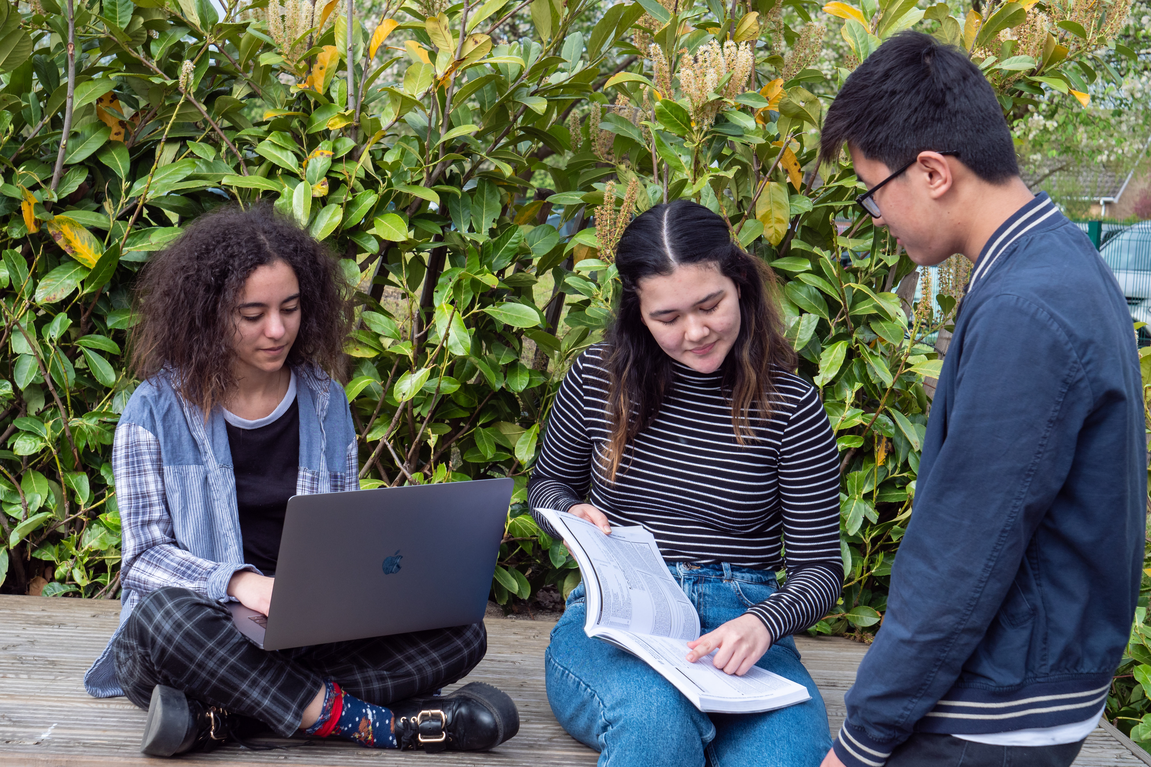

**Wider Impact**

Students will recognise the social inequalities around them. They will be compelled to look at power relationships within families, romantic and peer relationships as well as how family life continues to change and diversify.

Students will be driven to question the media as a source of information and consider who constructs their perception of reality and whether this construction is objective. This is particularly relevant in terms of “new” social media. They will be made to question taken for granted assumptions and stereotypes that have become entrenched in our media saturated society.

Students will need to examine the criminal justice system and the validity of crime statistics presented in the media and government documents alongside government policies to prevent crime. They will identify trends in offending behaviour and the social causes and explanations on the basis of class, gender and ethnicity

**Extra Challenge:**