

OCR GCSE COMPUTER SCIENCE – J277

Curriculum Intent
The OCR GCSE Computer Science course is structured to give students a solid foundation in computer science principles and practices, split into two main examination papers; component 1 - J277/01: Computer systems and component 2 -J277/02: Computational thinking, algorithms and programming

This curriculum aims to equip students with valuable thinking and programming skills that are highly attractive in the modern workplace, preparing them for further education and careers in computing and related fields.

“Computer science is the operating system for all innovation.” Steve Ballmer

Students will learn:

Knowledge, understanding & Skills
Key Concepts:
The aims of this qualification are to enable learners to develop:

● An understanding of and ability to apply the fundamental principles and concepts of computer science including; abstraction, decomposition, logic, algorithms and data representation.

• The ability to analyse problems in computational terms through practical experience of solving such problems including writing programs to do so.

• The capacity for thinking creatively, innovatively, analytically, logically and critically.

• The capacity to see relationships between different aspects of computer science.

• Mathematical skills.

• The ability to articulate the individual (moral), social (ethical), legal and cultural opportunities and risks of digital technology.

Component 1:
- System architecture
- Data representation
- Networks
- Network security and systems
- Impacts of digital technology

Component 2:
- Algorithms
- Programming
- Logic and Languages

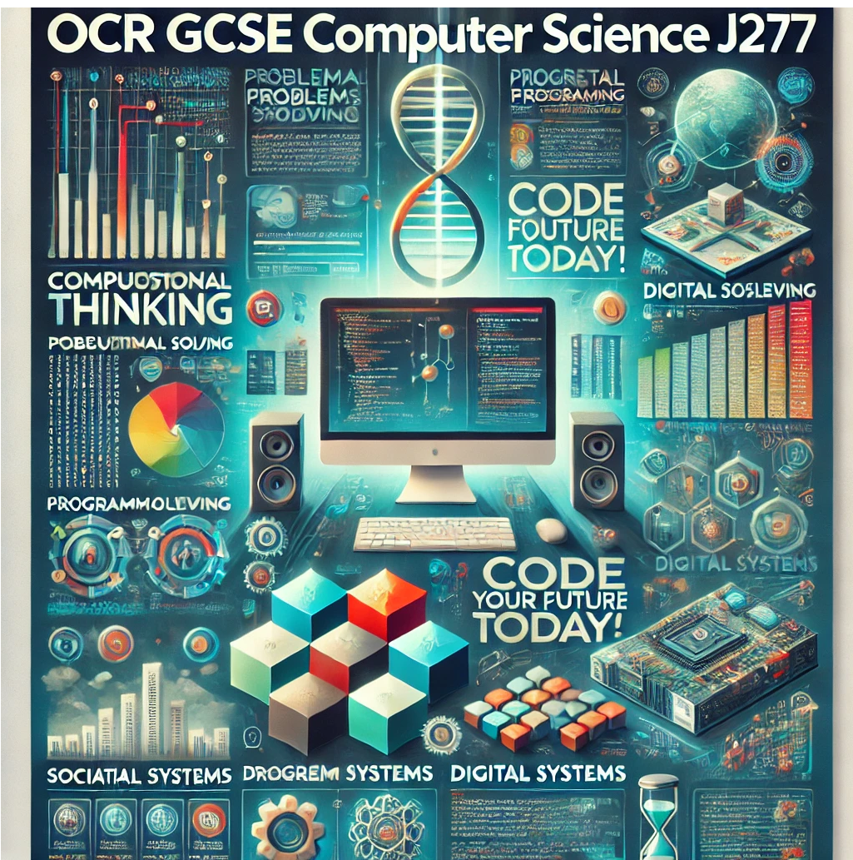
How will we assess impact?

● Regular half termly end of topic tests.
● Time2Code python challenges
● Formative assessment to take place within each lesson, using targeted questioning to make sure students understand the concepts they are utilising.
● Interactive model long answer building using Socrative.
● Through GCSE score board targeting gaps in knowledge
● Through timetabled PPE’s and Mini PPE’s

How can you enhance your learning at home?

● Utilising the revision guide and responding to feedback from teachers on what areas to focus on

● The resources utilised in class are available for students to access after the lesson on showbie and links will be posted where appropriate.

● Regular topic related homework, educational link will be made available to students to enhance their learning.

● Past paper questions will be given to students regularly as part of their deliberate exam practice. These will be reviewed by the teacher in the next lesson.
What does excellence look like?

Theoretical Understanding

• Develop a deep understanding of computational thinking: Students learn to apply fundamental principles such as abstraction, decomposition, logic, algorithms, and data representation.
• Provide insight into digital systems: Students gain knowledge about the components that make up digital systems, their communication methods, and their interactions with other systems.
Programming proficiency

• Ability to approach problems from multiple angles and develop innovative solutions including solving algorithms
• Use of creative methods in designing simple programs and solving complex problems.

Visits Programmes
- International Day
- Community lectures and work experience in computing related industries.
- Computing opportunities linked to international exchange programme.
- Visits to the National Computing Museum.

Within the curriculum
- Understanding how computing and technology affect societies and cultures worldwide.
- Awareness of global issues in computing such as data privacy, cybersecurity, and ethical considerations in AI.

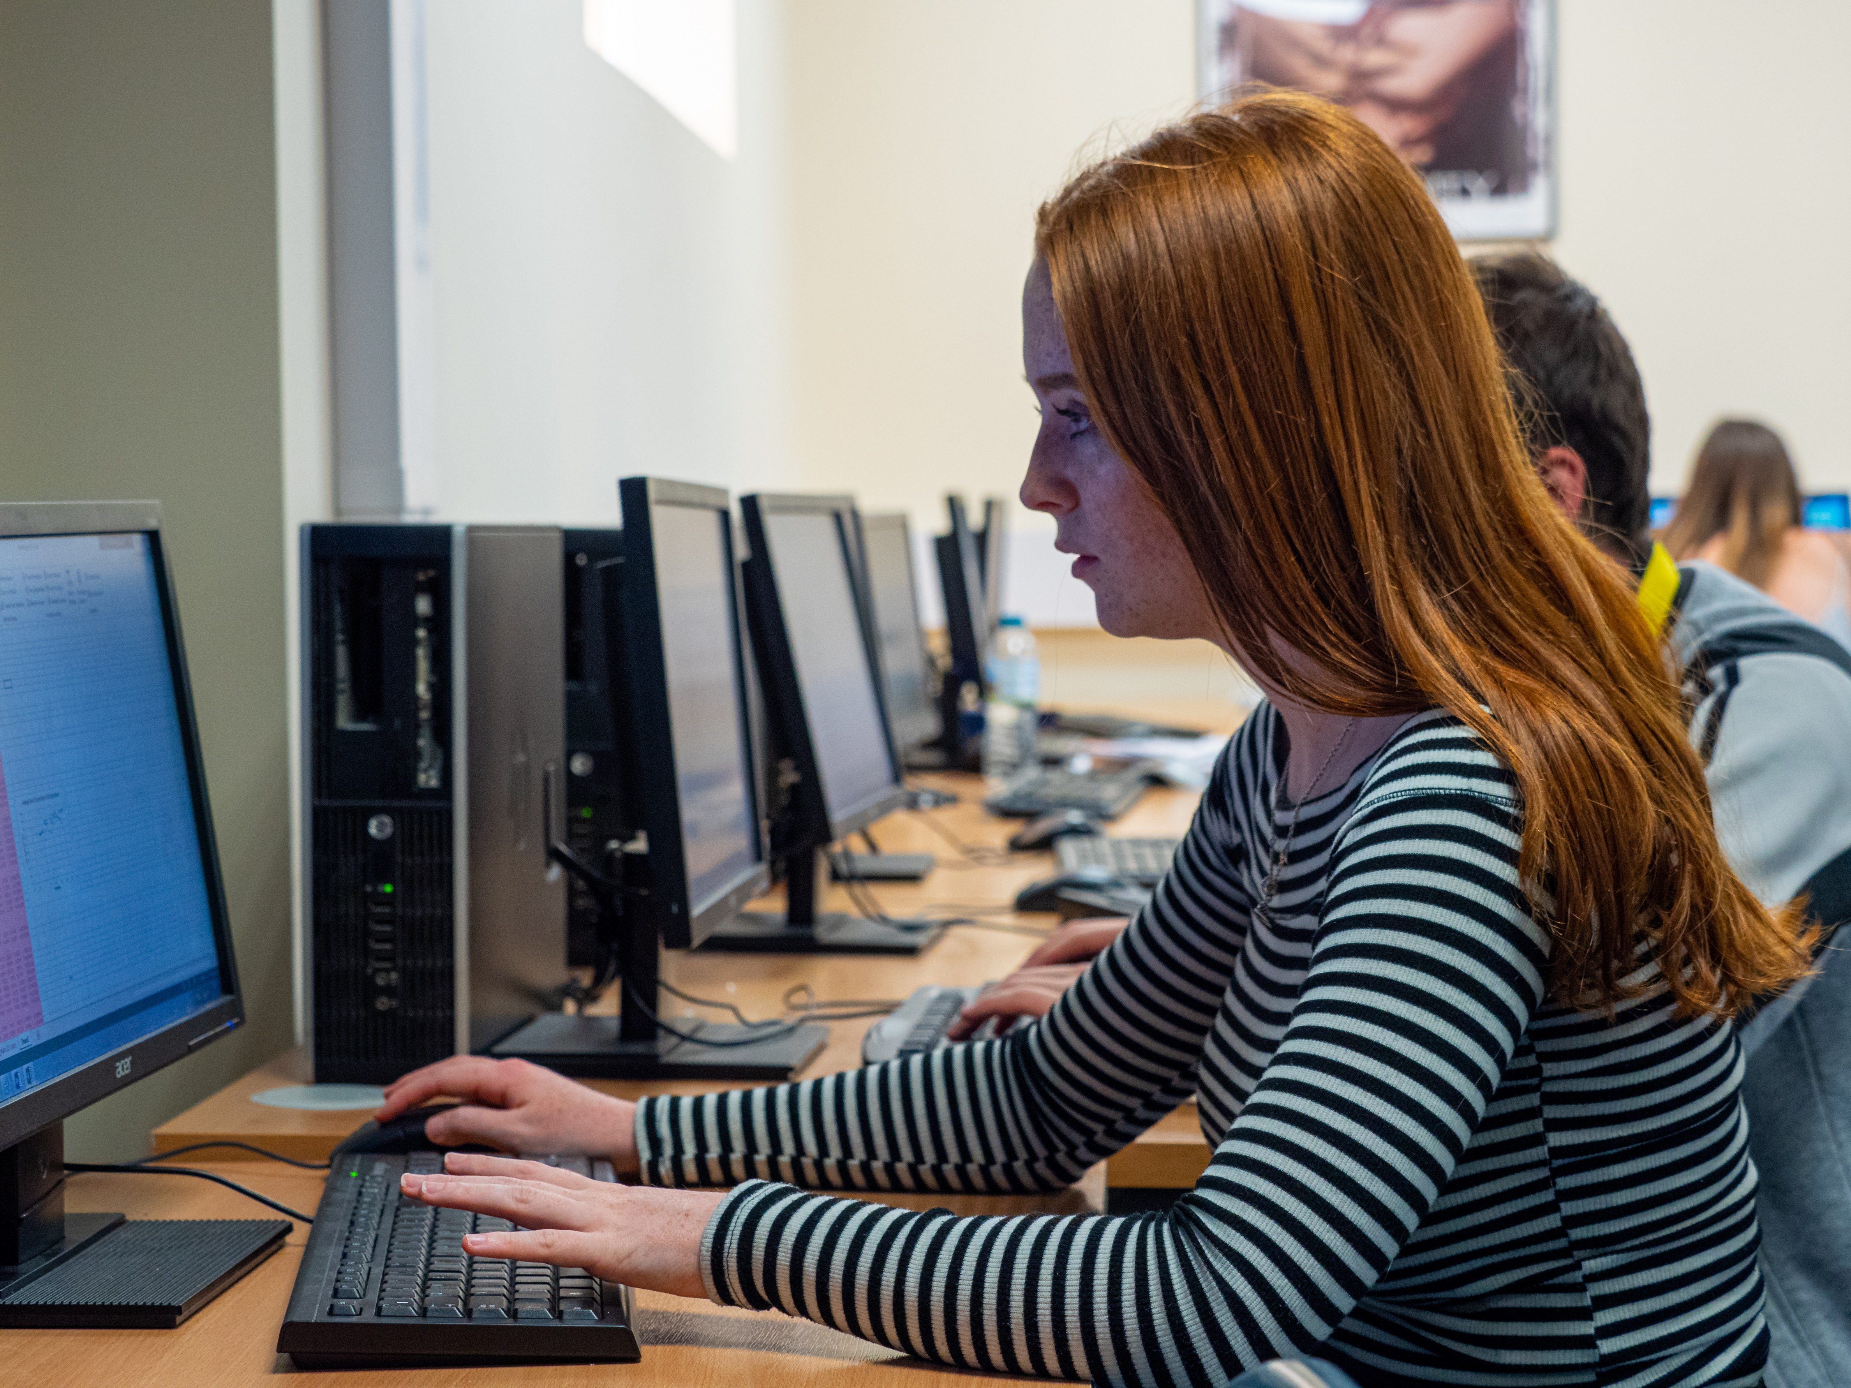
Further student development

- Students are given a PLC of topics they can study in their own time to make sure they have a variety of suitable examples to draw from.
- Students have the opportunity to apply their understanding through their own practical work on TIME2CODE and mini programming projects. This allows to demonstrate their understanding of Computational thinking, algorithms and programming.
- Participate in coding competitions like Bebras Challenge, CyberFirst, or national hackathons.
- •Join a computer science lunch time or after school club to explore advanced topics and share knowledge.

““Be curious, read widely, try new things. What people call intelligence just boils down to curiosity.” Aaron Swartz

Extra Challenge:

