

Geography Yr 7

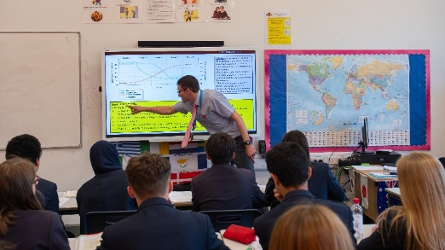
Students will learn:-
Fantastic Places
Place knowledge is key to understanding the geography around us. As geographers we need to be able to use a range of skills to help us identify the geography that we are seeing. In this unit students will travel around world completing core geographical skills (scale, distance, grid references) in a range of different environments – The Coral Reef, Antarctica, The Seven Wonders. This will allow them to start to enquire about the world around them. Students are introduced to the fundamental concepts of place, space and interdependence as well as the idea of scale (local, regional, national & international/global).

Cold Environments

This unit of work focuses on the key features of polar environments and incorporates mapping, literacy and numeracy links. Students use atlases to locate polar environments, explore the concepts of scale & distance in sea ice changes and draw population bar graphs. They analyse climate graphs and calculate mean & range of temperatures. Human adaptations are discussed and proposed linking to future issues linked to climate change.

What does Excellence look like?
Fantastic Places
This first unit will inspire in students a curiosity and fascination about the world and its people. Students will demonstrate an engagement with key processes and concepts which equip them with the synoptic elements of geography as a discipline.
Cold Environments
Apply their knowledge of climate change to future scenarios in the cold regions. For example, they will speculate about people in the polar regions and the future that exists for them in light of climate change.
How is homework used to enhance learning?
Homework focuses on key geographical skills, mathematical content and geographical concepts and processes. It aims to ensure that students embed their learning from the classroom into their long-term memory.
Assessment
Self-assessment
MCQ baseline skills online
End of unit formative assessments

Knowledge, Understanding & Skills
Fantastic Places:
To succeed in this unit students will be able to:​
Interpret a world map and locate specific geographical features​
Distinguish between human and physical geography providing examples of each​
Explain the threats to the coral reef ecosystem and rank their level of importance​
Explain the key features of Antarctica and why it is an important place​
Explain the Easter Island population collapse​
Develop and demonstrate competence in a range of skills, including 4 and 6 figure grid references, distance, scale and using an atlas​
Cold Environments:
State the main features of a glacial environment​
Explain the processes involved in the formation of a corrie​
Define and locate the tundra and taiga ecosystems​
Explain how the Inuit survive in the cold conditions of the Arctic​
Explain one type of erosion and how it shapes glacial landscapes​
State two adaptations of animals living in cold environments​
Plan and produce a piece of extended writing to explain what happened to the 'ice man' i.e. how geographical processes are key to understanding our past​
Understand a food web and describe the process of energy transfer​

Curriculum Intent
Our curriculum is designed to instil a love of Geography in all our students through developing their curiosity and fascination about the world and its people. We work hard to provide an interesting and varied curriculum that offers intrigue to our students helping to develop their knowledge and understanding of the Earth’s physical and human processes. Throughout their time at the Anglo European School students will be taught a variety of geographical terms applying them across different scales and places. We provide students with the opportunity to investigate their local place developing a real sense of who they are, their heritage and what makes their local place unique and special. We develop the following essential characteristics of geographers: an excellent knowledge of place location and characteristics; a detailed understanding of the ways in which places are interconnected; fluency in geographical vocabulary and questioning skills; excellent fieldwork skills; an ability to express informed opinions based on extensive research and understanding about current issues in society; a genuine interest in Geography and a sense of curiosity.
Autumn Term | Fantastic Places | Cold Environments
Knowledge, understanding & Skills

Hot Deserts:
Define and locate the desert regions of the world​
State the main features of desert climates​
Annotate and interpret a climate graph​
Explain the adaptations of desert plants and two desert animals​
Explain how the people survive in the hot and arid conditions of desert biomes​
Explain the causes of desertification​
Explain how desertification can be slowed down

Students will learn:-
This unit of work focuses on the key features of desert environments and incorporates mapping and numeracy links. Students use atlases to locate hot deserts and then apply the use of latitude to their answers. They draw and analyse climate graphs. Animal adaptations are discussed and survival techniques are shown to present ideas about the hot deserts as an extreme environment.

Spring Term | Cold Environments and Hot Deserts

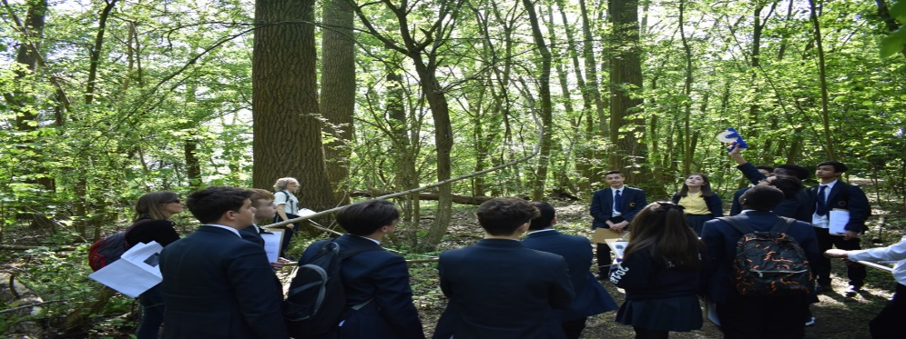

What does Excellence look like?
Hot Deserts
Use their own independent research to consolidate theory around why deserts are located where they are and future scenarios such as desertification. In addition they will look at the various stakeholders involved in hot desert environments and the future that exists for them in light of climate change

How is homework used to enhance learning?
In addition to term 1 ongoing embedded skills and understanding students will also be asked to practice their understanding of physical and human processes and sequencing.

Assessment
Self and peer assessment
MCQ on key terminology
End of unit formative assessment

Summer Term | Our Island Home

Students will learn:-

Students will be confident observing, measuring and recording the weather in both formal and informal ways.
They will be able to compare and contrast different weather systems both within our local area and with locations in other parts of the world.
This lays the groundwork for understanding our weather through extreme weather and climate change future contexts at Key Stage 4 and beyond. Being able to watch a weather forecast, read and interpret a weather map, and understand the changing nature of our weather are useful life skills.
Students will also be taught how to construct and analyse climate graphs in different regions.

Knowledge, understanding & Skills
Distinguish between the terms Weather and Climate​
Name equipment used and describe how the weather can be measured​
Interpret a synoptic chart using a key​
Explain the processes involved in the creation of clouds and precipitation​
Use fieldwork equipment to collect primary data​
Draw graphs to present data​
Answer an enquiry question using fieldwork data​
Describe the sequence of weather as a depression moves over a place​
​

Visits Programmes

Field work study in Montreuil sur Mer – map skills.
Town trails – St Omer and Montreuil
How will students be assessed?
Students will be proficient in discussing the complexities of the UK’s weather with reference to the complex system of air masses and air pressure systems. They will conduct a micro-climate fieldwork around the school site and write up as an investigation into suitable sites for new developments

What does Excellence look like?
Students will be given opportunities to design, conduct and analyse their own fieldwork investigations which can form part of the IB showcase summer event. This helps them to consolidate skills learnt across both this unit and the year.
Within the curriculum
• Visiting a range of different countries around the world
• Reflecting on the challenges and opportunities of indigenous peoples in hot and cold environments
• Human adaptations to extreme hot and cold environments
• Climate change futures and impacts
• Impact of local decisions on global futures on our island and the rest of the world

International Opportunities

