Chinese IB standard at AES
Textbook:
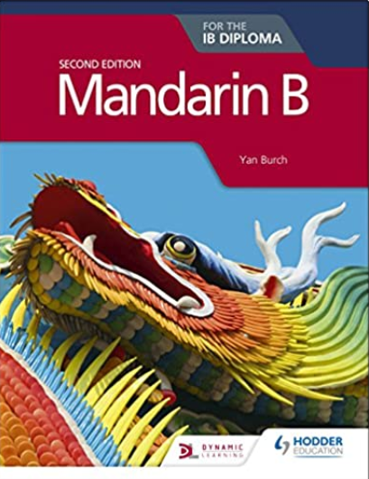 Mandarin B for the IB Diploma Second Edition
https://www.amazon.co.uk/Mandarin-B-IB-Diploma-Second/dp/1510446583/ref=sr_1_1?dchild=1&keywords=Mandarin+B&qid=1588845690&sr=8-1
Buy this book if you can.
Grammar book:
Mandarin B for the IB Diploma Grammar and Skills workbook
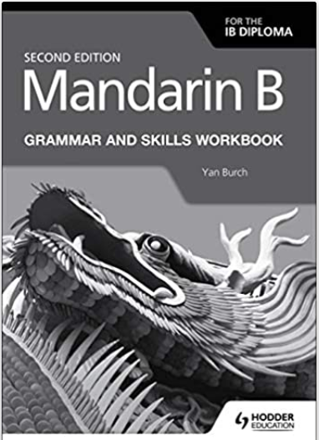https://www.amazon.co.uk/Mandarin-Diploma-Grammar-Skills-Workbook/dp/1510447628/ref=sr_1_3?dchild=1&keywords=Mandarin+B&qid=1588845874&sr=8-3
This would be a fantastic resource for you to work through before beginning the course in September.

The themes which we cover in the Chinese IB standard course are:
theme | Optional Topics | Possible questions
Identities | - Lifestyles  - Health and well-being  - Beliefs and values  - Subcultures  - Language and identity | - What constitutes and identity?  - How do we express our identity?  - What ideas and images do we associate with a healthy lifestyle?  - How do language and culture contribute to form our identity?
Experiences | 2.1 leisure activities  2.2 holidays and travel  2.3 Life stories  2.4 Rites of passage  2.5 Customs and traditions  2.6 Migration | - How does travel broaden our horizons?  - How does our past shape our present and our future?  - How and why do different cultures mark important moments in life?  - How would living in another culture affect our worldview?
Human ingenuity | 3.1 Entertainment  3.2 Artistic expressions  3.3 Communication and media  3.4 Technology  3.5 Scientific innovation | - How do developments in science and technology influence our lives?  - How do the arts help us understand the world?  - What can we learn about a culture through its artistic expression?  - How do the media change the way we relate to each other?
Social organisation | 4.1 Social relationships  4.2 Community  4.3 Social engagement  4.4 Education  4.5 Law and order | - What is the individual’s role in the community?  - What role do rules and regulations play in the formation of a society?  - What role does language play in a society?  - What opportunities and challenges does the 21st century workplace bring?
Sharing the planet | 5.1 The environment  5.2 Human rights  5.3 Peace and conflict  5.4 Equality  5.5 Globalisation  5.6 Ethics  5.7 Urban and rural environment | - What environmental and social issues present challenges to the world, and how can these challenges be overcome?  - What ethical issues arise from living in the modern world, and how do we resolve them?  - What challenges and benefits does globalisation bring?  - What challenge and benefits result from changes in urban and rural environments?

Specific Bridging work
Check if you understand how to use all these grammar. Create your own sentences use the grammar you know, highlight the grammar you don’t know, check it on Chinese Grammar Wiki.
Grammar check list: https://angloeuropeanschool.sharepoint.com/sites/LANG/Chinese/Forms/AllItems.aspx?id=%2Fsites%2FLANG%2FChinese%2F6%2E%20Lessons%5FAES%2F6%2E6%20IB%20ab%20initio%2FIB%20Chinese%20Grammar%20Check%20List%2Epdf&parent=%2Fsites%2FLANG%2FChinese%2F6%2E%20Lessons%5FAES%2F6%2E6%20IB%20ab%20initio

Useful Chinese websites
It is always a good idea to keep listening to as much authentic Chinese as possible as regularly as possible. You should aim to tune into a Chinese radio station online, this is easy with a quick google search for Radio Garden. Simply move any city in China.
北京音乐广播: http://radio.garden/listen/fm-97-4/zYjhvVaJ
There are many videos you youtube, about IB and A Level
Slow Chinese on youtube
BBC News Chinese: https://www.bbc.com/zhongwen/simp
Chinese Grammar Wiki: https://resources.allsetlearning.com/chinese/grammar/

