Economic Summer Reading “Grab Bag”

*Each chapter has been hyperlinked to the PDF so do not need to go and buy the book. Press “ctrl” and click on the link to access it

Book Cover | Authors | Chapter Title* | Brief Description
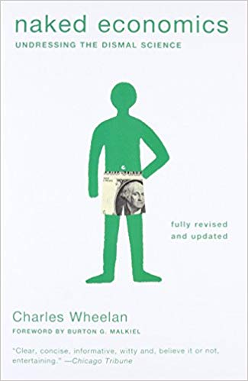 | Charles Wheelan | Development Economics | If you were here in 9th grade you may remember listening to Dr. Wheelan talking to you as he visited the school a few years ago.  This first chapter gives a great overview of development economics which examines how countries can can improve the quality of life for their citizens.
 | Charles Wheelan | Incentives Matter | There are many issues that governments and people alike face. In this chapter Dr. Wheelan examines how looking not necessarily at the problem, but the incentives to the behavior is a more effective way to generation solutions.
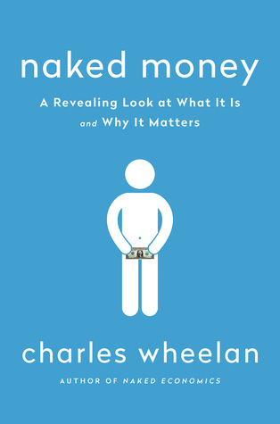 | Charles Wheelan | The United States & China | Dr. Wheelan wrote another book for his ‘Naked’ series. This one though takes a deep dive into the ideas about money.  In the news lately you probably have heard a lot about Trump and China. Dr. Wheelan does a good job of laying out what some of the issues are, particularly as it relates to currency.
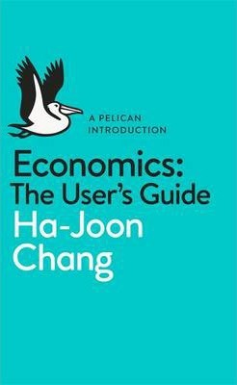 | Ha-Joon  Chang | Leviathan or Philosopher King? | Ha-Joon is another great economics writer who can simplify often times complicated economic concepts.  In this chapter he examines the role that governments can play in the not only in society, but in the economy as well. Spoiler alert: The government can be both good and bad.

*Each chapter has been hyperlinked to the PDF so do not need to go and buy the book

Book Cover | Authors | Chapter Title* | Brief Description
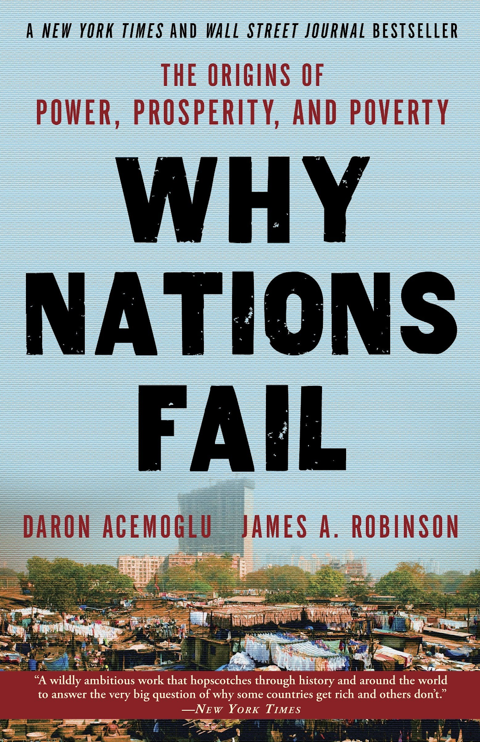 | Daron Acemoglu &  James A. Robinson | Drifting Apart | As the title suggests the authors explore why some nations are more successful than others. Their main argument that more successful nations have inclusive institutions that make their economies strong. In this chapter they explore why Venice went from a major trading port to a tourist trap. They also examine the role that institutions played in the fall of Rome.
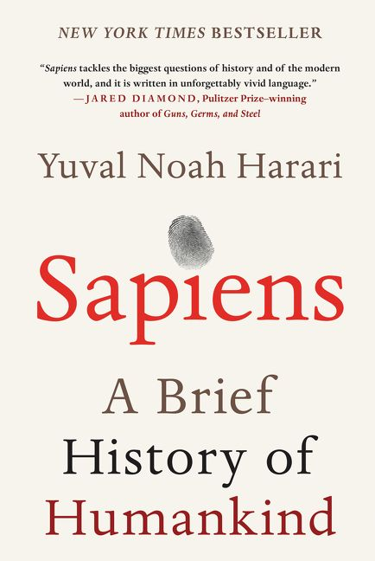 | Yuval Noah Harari | Capitalist Greed | Perhaps one of the best books I’ve read in the past few years. In this chapter Yuval explores the history of capitalism as we know it today and points out that many of the ideas we believe in have only been around for the past 100 years.
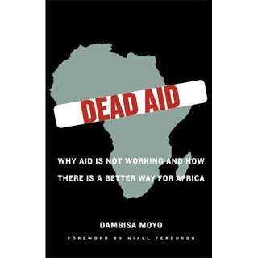 | Dambisa Moyo | Aid Is Not Working | As you can probably guess from the title, Dambisa Moyo argues that foreign aid is no longer benefiting the nations of Africa. While her book goes into more detail and examples, this chapter helps lay out the foundation for her argument.
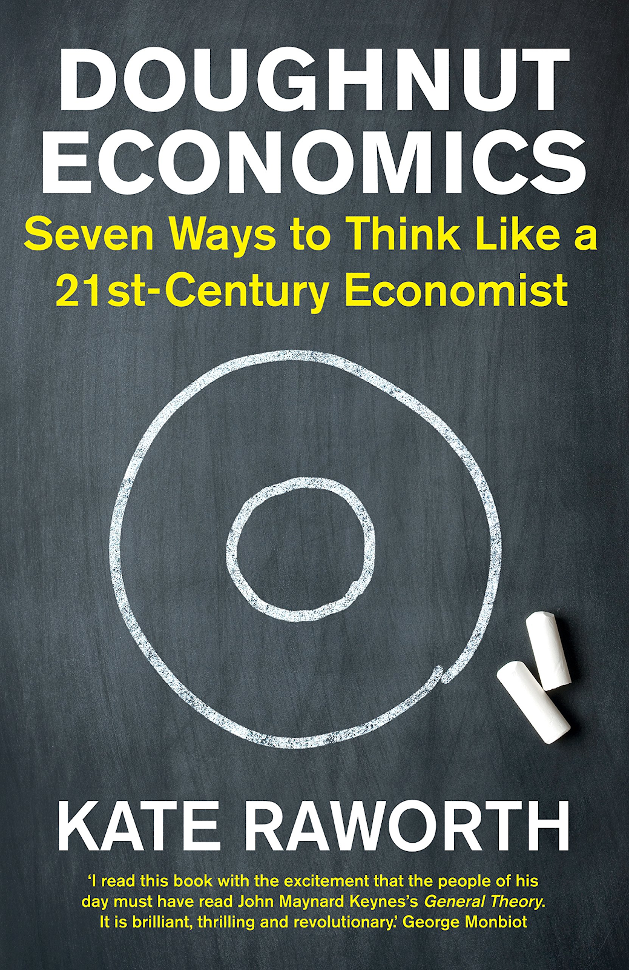 | Kate  Raworth | Change the Goal:  From GDP to the Doughnut | Recent news about global warming and the downward spiral of the planet have had many economists re-examine many accepted theories and concepts that have been taught in the past.  Ms. Raworth is on the forefront of this movement as she examines one of the most well known economic indicators, GDP and why it we need to re-evaluate its importance.

