Geography Bridging Work – GCSE to A Level/IB
Reading List
A key part of the transition from GCSE to sixth form study is independent reading. Reading over the coming months will not only help you retain some of your subject knowledge from GCSE that you will build on at A Level or in the IB, but it will also help to develop your critical thinking skills as well as improving the quality of the analysis and evaluation in your written work.
This reading list is not exhaustive but includes a range of accessible yet academically rigorous books that will help you prepare for the key topics taught in the Lower Sixth. The list has also been compiled with reading for pleasure in mind and therefore if you are genuinely interested in geography, reading any of these whilst on holiday post-coronavirus should not feel like a burden!
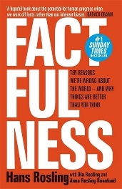
General Reading
Factfulness by Hans, Ola and Anna Rosling
If you only read one book this summer, make it this one! It sets out why many people are ignorant about the world and what we can do to make ourselves more informed. We guarantee that reading this will make you think twice about saying “In Africa…” and then making sweeping generalisations that are not based on facts. You will also never be outguessed by a chimpanzee ever again!
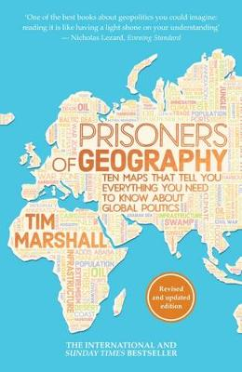
Prisoners of Geography by Tim Marshall
If you are fascinated by geopolitics then along with Divided by the same author, this is the book for you. If you are interested in why Putin is so obsessed with Crimea, why the USA was always destined to be a superpower, or why China’s influence continues to expand ever outwards, look no further.
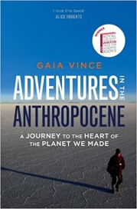
Adventures in the Anthropocene by Gaia Vince
Quite simply one of the best books Mr Wilkes has read in the last two years! An excellent read for both A Level and IB students regardless of your specific areas of interest because it will get you thinking synoptically (making connections between different areas of the subject). The last chapter that predicts what life will be like at the end of the 21st century might be the most thought-provoking part of the whole book.

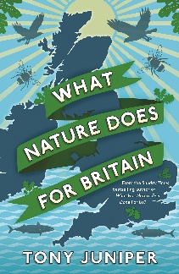
A Level Water & Carbon Cycles
What nature does for Britain by Tony Juniper
An accessible book that covers many of the key themes you will study in the Water and Carbon Cycles unit including the importance of soils, freshwater as a resource, flooding, climate change and energy. It does an excellent job at showing the interconnections between water and carbon, something that you will need to be able to do as an A Level student. Whilst Chapters 1 and 4-7 are most useful for a geographer, those of you looking to study Biology may find the rest of the book interesting.

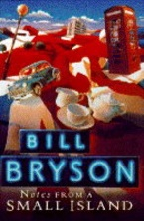
A Level Changing Places
Notes from a Small Island by Bill Bryson
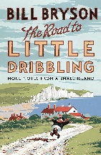
Notes from a Small Island is a hilarious travel book that was voted in a BBC poll as the book that best represents Britain. As a result, it provides a perfect introduction to the Changing Places unit where A Level students will be asked to think about places as locations with meaning. The Road to Little Dribbling by the same author marks the twentieth anniversary of Notes from a Small Island and therefore would make the perfect follow-up read.
Alternatively, feel free to read any material that relates to the places you are most connected to. How are you connected to these places? Why do these places have meaning to you? How are these places represented in books, magazines, newspapers, social media, photographs, art and poetry?
A Level Coasts
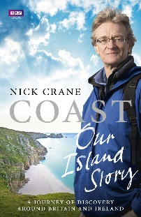
It is difficult to recommend books for coastal landscapes unless you would like to read a textbook! The two books below cover the geography and history of our coastline and provide insights from those that call the coast their home.
Coast: Our Island Story: A journey of discovery around Britain’s coastline by Nicholas Crane
Coastlines: The story of our shore by Patrick Barkham
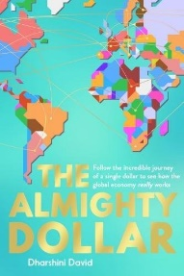
A Level Global Systems & Governance and IB Power, Places & Networks (HL students only)
The Almighty Dollar by Darshini David
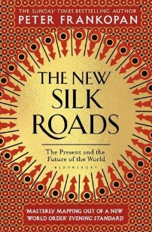
Follow the incredible journey of a single dollar to see how the global economy really works. This book builds on familiar content from GCSE e.g. oil in the Niger Delta and is a must-read for any student interested in economic geography or is studying economics alongside geography. It reveals the economic forces shaping our lives – who really holds the power, and how that affects us all.
The New Silk Road by Peter Frankopan
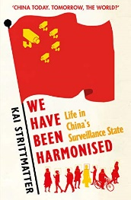
Despite the fact that Peter Frankopan is a historian, this is an excellent book about geography that focuses on globalisation and our interconnected world. Following the Silk Roads eastwards from Europe through to China, this book maps out a new world order and the continual shifts in power to the east. If you are a history student, you may also be interested in Frankopan’s first book The Silk Roads: A New History of the World.
We have been Harmonised by Kai Stittmatter
Kai lived in China for over 30 years and has studied historical and cultural notions that are essential to our understanding of the biggest economic powerhouse in the world. As China develops its society through a complex surveillance system (facial recognition, algorithmic controlled programs etc) this is an opportunity to think critically about the impacts of this across a variety of scales.

IB Freshwater
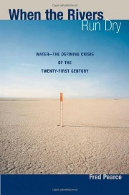
When the rivers run dry: The global water crisis and how it is solved by Fred Pearce
This book explores water scarcity through a huge range of examples from around the world, some of which are key case studies for IB students. Whilst his findings are shocking, he also offers hope for the future – if we can radically revolutionize the way we treat water, and take responsibility for the water we use.

IB Population change and Global resource consumption and security
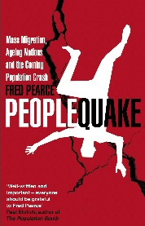
Peoplequake: Mass migration, ageing nations and the coming population crash by Fred Pearce
A must-read in preparation for these two core units in the IB. With global population predicted to reach 10 billion this century, Pearce provides insight into the relationship between global population and resources over time, and how the ‘population bomb’ is being refused. You may also like to read 10 Billion by Stephen Emmott and 10 Billion by Danny Dorling in conjunction with Peoplequake to appreciate the debate that surrounds population growth and resources in the 21st century.

Divided: Why we’re living in an age of walls by Tim Marshall
Another excellent book for those students interested in geopolitics. For anybody interested in migration, this looks at the current situation in North America and Europe in a way that will support your studies of population change in the IB.
News & Magazines
Along with the books recommended above, reading about the geographical topics that you are interested in the news will keep you up-to-date with what is happening right now.
The BBC
https://www.bbc.com/news
Your first port of call for unbiased in-depth news. Download the app to your smart phone and customise My News to show the geographical topics that you are most interested in.
The Guardian
https://www.theguardian.com/uk
One of the most trusted sources of news in the UK, the Guardian publishes excellent articles on a range of geographical topics with the depth of analysis and critical thought that is expected from you as an A Level or IB student.
The Economist
https://www.economist.com/
A weekly newspaper that is about far more than economics, business and finance. If you are interested in geopolitics, this is a must-read every week. In addition, it covers a broad range of geographical topics including in-depth and analytical special reports on issues such as global water security, globalisation, climate change and migration. You need a subscription to read the Economist but there is likely to be a special offer running e.g. 12 issues for £12 to get you started.
Geographical Magazine
http://geographical.co.uk/
The magazine of the Royal Geographical Society (RGS) is published monthly and contains illustrated articles on people, places, adventure, travel and environmental issues as well as a summary of the latest academic research in geography.
Podcasts
The following podcasts are recommended and will be used throughout the A Level and IB courses to support independent learning. Check them out on your preferred podcast platform – the BBC podcasts are available online and through the BBC Sounds app.
Ask the geographer
https://www.rgs.org/schools/teaching-resources/ask-the-expert-podcasts/
An excellent podcast produced by the Royal Geographical Society. The RGS interview a range of geographers about their current research to help keep your case studies up-to-date.
GA Geogpod
https://www.geography.org.uk/GeogPod-The-GAs-Podcast
A new podcast from the Geographical Association (GA) that includes interviews about teaching and learning as well as the latest geographical research. The latter is most relevant for students. Check out episode 1 if you are interested in coastal landscapes!
BBC The Inquiry
https://www.bbc.co.uk/programmes/p029399x/episodes/downloads
A brilliant podcast from the BBC World Service that focuses on one question, ideas from four expert witnesses and an answer. There are a host of geographical questions in the archive. For IB students, check out the podcasts about water scarcity in Cape Town and Chennai.
BBC Thinking Allowed
https://www.bbc.co.uk/programmes/b006qy05/episodes/downloads
Another excellent podcast from the BBC World Service. Search for the disasters episode - it is a must-listen for all A Level and IB students for their hazards units in the Upper Sixth.
TED Talks
https://www.ted.com/talks
TED talks are short, powerful talks that focus on “ideas worth spreading” There is a wealth of geographical talks on the website. As a starting point, check out anything by Hans Rosling as well as Parag Khanna’s talk on how megacities are changing the map of the world.
Learning Activities
Detailed below are 5 learning activities that you should aim to complete before you start studying geography in the Sixth Form. Along with the other resources provided here, they have been designed to keep you thinking geographically over the summer months and help you to make the transition from GCSE to A Level/IB
1. Download, print and read the relevant syllabus for the course you will be studying (IB or A Level) to understand what you will be studying in each topic and how the material will be examined.
2. Take the Gapminder Test, explore the Dollar Street website, play with the data on the Gapminder website, watch Hans Rosling’s TED Talks and read Factfulness. Ensure that you start your sixth form studies with a fact-based view of the world and you will never be out-guessed by the chimpanzees!
https://www.gapminder.org/
3. Watch Parag Khanna’s TED Talk on how megacities are changing the world.
- What ideas does Khanna present?
- To what extent do you agree with them?
This is a challenging activity but it will give you some exposure to how you will be expected to think as an A Level/IB geographer.
https://www.ted.com/talks/parag_khanna_how_megacities_are_changing_the_map_of_the_world?language=en
4. Read through the extract provided from James Rebank’s book The Shepherd’s Life and answer the following questions:
- How does the teacher portray the Lake District in her assembly?
- How was the Lake District seen up until 1750? How did this change?
- How do James Rebanks and other locals experience the Lake District?
- How is the Lake District an example of a contested place?
This will give you an idea of what it will be like to study place as a concept at A Level.
5. Complete one (or more!) of the free courses available online through Open Learn. Check out the geography-related courses on offer in Nature & Environment, Science, Maths & Technology or Society, Politics & Law. Pick something that interests you based on what you will be studying next academic year and have a go!
- Introductory courses should consolidate your knowledge and understanding from GCSE and provide a stepping stone to studying in the Sixth Form.
- Intermediate course broadly replicate the level of detail required to achieve a top grade at A Level and in the IB.
- Advanced courses include material that is equivalent to undergraduate study at university.
https://www.open.edu/openlearn/subject-information
Watch "Before the Flood" Documentary
Before the Flood Full Movie National Geographic
Answer the following questions in full sentences
- What is the main topic of the documentary "Before the Flood"?
- Describe the role of Leonardo DiCaprio in the documentary.
- List three key environmental issues highlighted in the film.
- How does the documentary portray the impact of climate change on wildlife and ecosystems?
- Identify at least two examples of sustainable solutions presented in the film.
- Explain the concept of greenhouse gases and their role in climate change.
- What is the significance of the Paris Agreement discussed in the documentary?
- Reflect on your own understanding of climate change before watching the documentary. How has your perspective changed after viewing it?
- Research one environmental organization or initiative that is actively working to address climate change.

