German A-Level at AES
Important materials
The textbook we use for both years of the A-Level course is published by Hodder. You should buy your own copy, if you can, as it will be useful both for classwork and for revision when the time comes. It is available on Amazon if you click here.
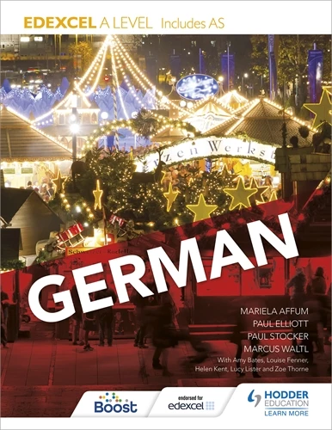

The textbook is supported by two workbooks, which focus on the grammar we will cover together. These are well worth buying, too, again so that we can use them in class and so that you can come back to them when you need to revise. The first workbook is available from Amazon here, and the second one here.
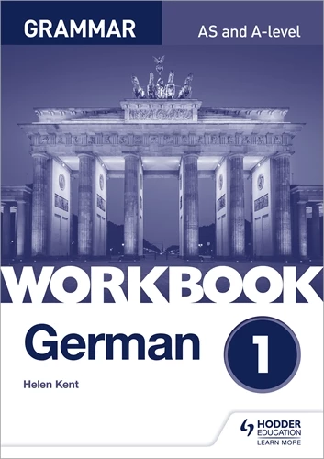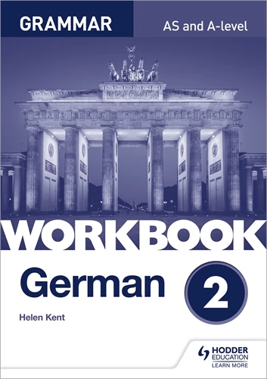

Course content
The themes which we cover in the German A-Level course are:
Thema 1 | Gesellschaftliche Entwicklung in Deutschland | Natur und Umwelt  Bildung  Die Welt der Arbeit
Thema 2 | Politische und künstliche Kultur im deutschen Sprachraum | Musik  Die Medien  Die Rolle von Festen und Traditionen
Thema 3 | Immigration und die deutsche multikulturelle Gesellschaft | Die positive Auswirkung von Integration  Die Herausforderungen von Immigration und Integration  Die staatliche und soziale Reaktion zur Immigration
Thema 4 | Die Wiedervereinigung Deutschlands | Die Gesellschaft in der DDR vor der Wiedervereinigung  Ereignisse vor der Wiedervereinigung  Deutschland seit der Wiedervereinigung

We will also study two cultural topics:
Lower Sixth | Film | Das Leben der Anderen by Florian Henckel von Donnersmarck
Upper Sixth | Play | Der Besuch der alten Dame by Friedrich Dürrenmatt

It would be a very good idea to watch this film online or buy a copy of the DVD, available here on Amazon, before studying it. You should also buy a copy of the play to read in advance, if possible both in German (the version we will read together in class can be found on Amazon, here), and in English (a good version is here).
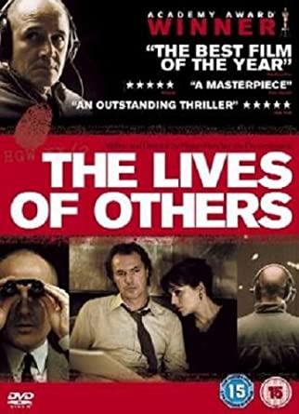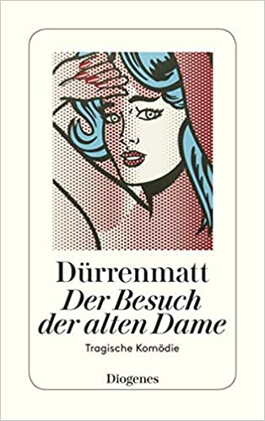

Looking further ahead, you will have to prepare an independent research project (IRP) in the Upper Sixth which will form the basis of your final speaking exam at the end of the course. You can choose absolutely anything of interest to you as long as it is grounded in German-speaking culture (so Austrian or Swiss topics are fine too).

Bridging work before the start of the course
Cultural topics: try to get hold of the film and the play (see above) so that you are familiar with them before the start of the course.
Grammar: try to master the grammar that was covered as part of the GCSE course, as it will be built upon during the A-Level course. There is an excellent grammar and translation workbook you can use to help you, which is available here on Amazon.
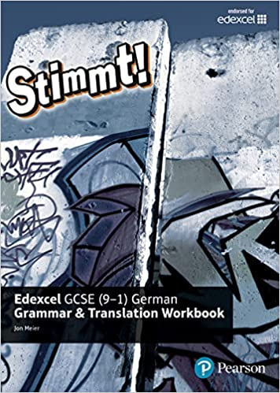

Translation: this accounts for 40 marks across two exam papers. You will have to be able to translate confidently and accurately from German into English, and from English into German. The mark scheme is very strict, so as much grammar practice as possible (using the above grammar books or online drills) is vital. Here are some examples of some “easy” translation exercises for you to have a go at:
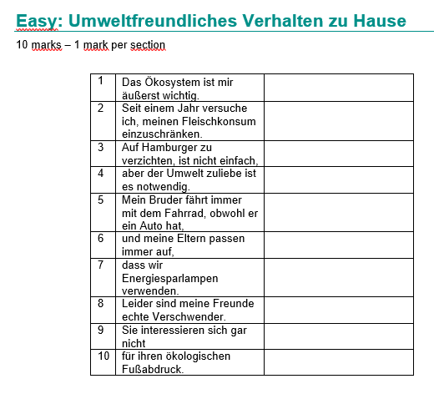
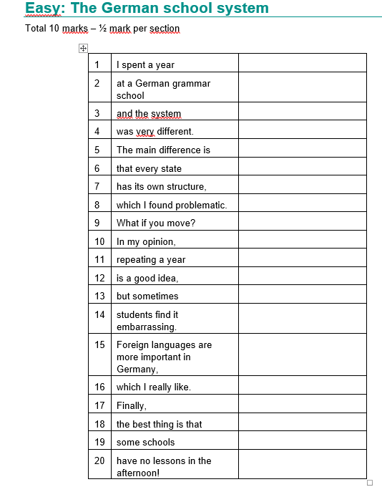

IRP: you might wish to start thinking about this now and do a bit of preparatory research online. Some ideas from previous cohorts include:
The Bundesliga and its specific 50+1 rule
Germans and their love of alcohol: is it possible to celebrate in Germany without having a beer?!
Ostalgie and how it is presented in German cinema
The Bauhaus architecture movement
The rise and fall of the German Tennis Association
Helmut Kohl and his political legacy
Aldi supermarket – how did it become so successful?

Useful German websites
The first port of call should be the AES German padlets. There is one set up for general Sixth Form learning and extension work here, and another specifically for A-Level here.
It is always a good idea to keep listening to as much authentic German as possible as regularly as possible. There are some excellent series on Netflix, including the science-fiction series Dark, which you can watch with subtitles. You can also subscribe to News in Slow German, which includes transcripts to read.
The Goethe Institut is an excellent source of information. We are close enough that you can visit their building in Kensington, but their website also has lots of information on the latest developments in Germany and events that are taking place in London.
The Deutsch XXL section of the Deutsche Welle website has lots of activities and information aimed at learners, and the Nicos Weg story on the same website is also very useful and, hopefully, fun!
Other sites to dip into when you can are the Reverso German verb conjugator (more reference than anything, but useful nonetheless), Spiegel for the latest news, and DaF for plenty of worksheets on various themes and grammar points.

German IB at AES
Important materials
The coursebook we use for both years of the IB course (Standard and Higher) is published by Cambridge. You should buy your own copy, if you can, as it will be vital both for classwork and for revision when the time comes. It is available on Amazon if you click here.
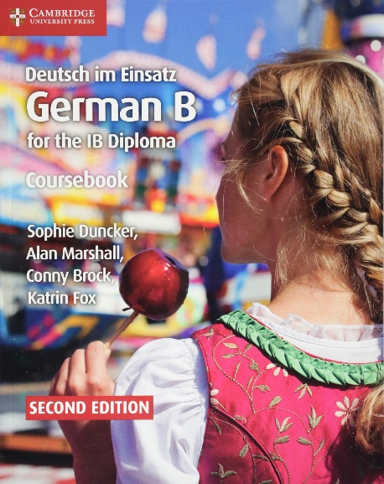

The coursebook is supported by a workbook, which is full of IB-style questions for you to work through. This is well worth buying, too. The workbook is available from Amazon here.
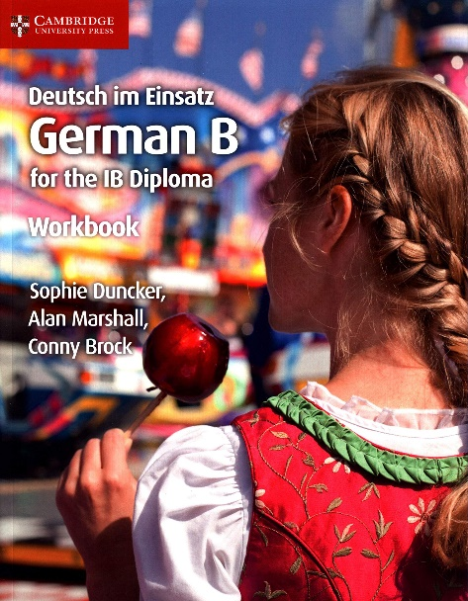

Course content
The themes which we cover for Standard and Higher German IB are:
Thema 1 | Identitäten | Wer bin ich?  Gesundheit und Wohlbefinden  Werte und Glauben  Wir und die Anderen
Thema 2 | Erfahrungen | Prägende Einflüsse  Eine kulinarische Reise  Feste und Traditionen  Die Sehnsucht nach dem Leben
Thema 3 | Menschliche Erfindungsgabe | Fernsehen: die Macht des Publikums  Kino mal auf Deutsch  Musik heute  Werbung: Spaß, Verdummung oder Manipulation?
Thema 4 | Soziale Organisation | Die digitale Welt  Jugend heute – und die Menschen um sie herum  Schule – für das Leben  Die geregelte Welt
Thema 5 | Ein Planet für alle | Der Mensch als globaler Konsument  Der Mensch in der Natur  Der Mensch und seine Mitmenschen  Der Mensch braucht Energie

For the Higher course will also study two cultural topics:
Lower Sixth | Play | Andorra by Max Frisch
Upper Sixth | Play | Der Besuch der alten Dame by Friedrich Dürrenmatt

It would be a very good idea to buy a copy of each of the plays to read in advance, if possible both in German (Andorra can be found here, Der Besuch der alten Dame here), and in English (Andorra here, and The Visit here).
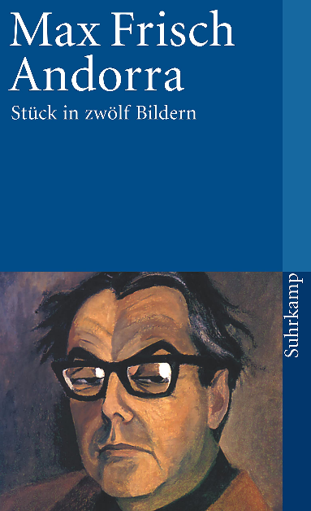

Bridging work before the start of the course
Cultural topics (for Higher only): try to get hold of the plays (see above) so that you are familiar with them before the start of the course.
Grammar: try to master the grammar that was covered as part of the GCSE course, as it will be built upon during the A-Level course. There is an excellent grammar and translation workbook you can use to help you, which is available here on Amazon.

IB reading skills: there are some very specific skills required by the IB examinations, so it would be a great idea to get hold of the workbook listed above to start looking at the sorts of things you can expect.

Useful German websites
The first port of call should be the AES German padlets. There is one set up for general Sixth Form learning and extension work here, and another specifically for IB here.
It is always a good idea to keep listening to as much authentic German as possible as regularly as possible. There are some excellent series on Netflix, including the science-fiction series Dark, which you can watch with subtitles. You can also subscribe to News in Slow German, which includes transcripts to read.
The Goethe Institut is an excellent source of information. We are close enough that you can visit their building in Kensington, but their website also has lots of information on the latest developments in Germany and events that are taking place in London.
The Deutsch XXL section of the Deutsche Welle website has lots of activities and information aimed at learners, and the Nicos Weg story on the same website is also very useful and, hopefully, fun!
Other sites to dip into when you can are the Reverso German verb conjugator (more reference than anything, but useful nonetheless), Spiegel for the latest news, and DaF for plenty of worksheets on various themes and grammar points.

