

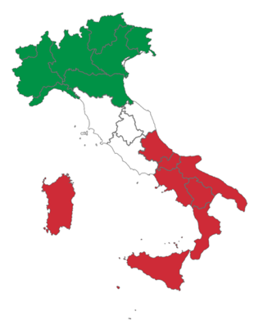

Italian IB ab initio

This is a course for students with very limited or no prior experience of the language.

Topics covered in this course

Personal attributes
Daily routine
Leisure
Holidays
Festivals and celebrations
Eating and drinking
Physical well-being
Transport
Entertainment
Media
Technology
Neighbourhood
The workplace
Education
Social and global issues
Climate
The environment
Physical geography

List of recommended sources and tasks

- Alphabet and pronounciation: how do pronounce vowels in Italian?
http://www.bbc.co.uk/languages/italian/guide/alphabet.shtml
https://www.iwillteachyoualanguage.com/learn/italian/italian-tips/italian-pronunciation-guide

- Common words and phrases: make a list of 30 useful phrases and learn them by heart
https://www.walksofitaly.com/blog/travel-tips/italian-words-and-phrases
https://www.dummies.com/languages/italian/italian-for-dummies-cheat-sheet/

- Basic vocabulary: learn the numbers from 1 to 100, write the days of the week and months
https://onlineitalianclub.com/italian-vocabulary-lists-and-exercises/

- Basic grammar: can you explain the rule of the Italian nouns? Read and make some notes
http://www.italianlanguageguide.com/grammar/nouns/
https://en.wikibooks.org/wiki/Italian/Nouns

- Facts about Italy: find information about aspects of the country and culture you are interested in such as art, history, sport, food, literature
https://www.livescience.com/44376-italian-culture.html
https://italianbureau.com.au/italy-facts-and-tips/50-facts-and-more-about-italy/

- Watch an Italian film or series: currently on Channel 4 Mafia Only Kills in Summer
https://www.channel4.com/programmes/mafia-only-kills-in-summer

- Start learning Italian on Memrize: practise basic language and pronunciation
https://www.memrise.com/courses/english/italian/

