

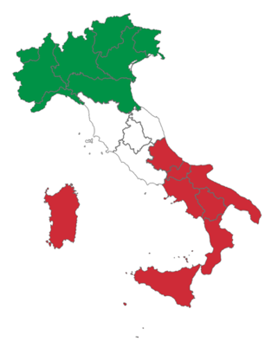

Italian IB Standard Level

This is a course for students with prior experience of the language.

Topics covered in this course

Lifestyle
Health
Beliefs and values
Subcultures
Language and identity
Travel
Life stories
Rites of passage
Traditions
Migration
Artistic expressions
Media and technology
Scientific innovation
Work and education
Law and order
Community and social relationships
The environment
Human rights
Peace and conflict
Globalization
Ethics
Equality

Compulsory tasks
GRAMMAR revision: you need to be confident using the following tenses and grammar structures.

- Present tenses
- Past tenses (passato prossimo e imperfetto)
- Future simple Modal verbs (dovere/potere/volere/sapere)
- Conditional (present)
- Prepositions
- Pronouns
- Subjunctive present and imperfect

Explore these websites, find the ones that work for you. Create a verb conjugation chart.
https://www.almaedizioni.it/it/almatv/grammatica-caffe/
http://www.oneworlditaliano.com/grammatica-italiana/pronomi_combinati.htm
http://www.zanichellibenvenuti.it/wordpress/?p=1717
http://www.impariamoitaliano.com/index.htm
https://www.iluss.it/schede_gram_free.html
http://www.speakitalian.org/exercises--esercizi.html

LISTENING
https://www.newsinslowitalian.com/
Choose a piece of news, listen and summarize it in English. Listen again, summarize it in Italian.

READING start reading authentic texts.
- Read the following article about changes in the Italian family. Make some bullet points to help describe current trends and changes.
https://www.repubblica.it/cronaca/2019/12/30/news/istat_la_famiglia_italiana_sempre_piu_piccola_il_33_e_single_-244636735/?refresh_ce

- Read about migration. Summarize the article. Make a list of words that you could use to write or talk about this topic.

https://www.repubblica.it/solidarieta/immigrazione/2019/07/03/news/migrazioni-230220063/

WRITING Become familiar with different text types, formal and informal. Follow the link for a list of text types for IB languages.
https://www.thinkib.net/englishb/page/18615/specific-text-type-skills

- Write a short article (200 words) about how travel can broaden our horizons.
- Now write a blog about how travel can broaden our horizons.
Reflect on the difference in purpose, organization and style for the two tasks.

Recommended tasks
- Research some of the topics of this course.
- Read Italian magazines and short articles.
- Read short stories in Italian (or graded readers) https://italiano.sismondi.ch/letteratura/testi-brevi

- Listen to the Italian radio http://radio.garden/
- Watch an Italian film or series: currently on Channel 4 Mafia Only Kills in Summer
https://www.channel4.com/programmes/mafia-only-kills-in-summer

