Music: GCSE to A-Level Bridging Work
Task 1:
Keep playing and singing.
Your skills will deteriorate if you don’t maintain a decent rigorous practice schedule. If you have an instrumental/vocal teacher - make sure they know you are doing A level
At this level you should be doing structured meaningful practice for at least 30 mins every day. If you’re not sure how to do that, then talk to me and/or your instrumental/vocal teacher.

Task 2:
Keep composing. Don’t let your composing skills get rusty.
Don’t spend any money - you can use free trial versions of the following composing packages over the summer
BandLab https://www.bandlab.com/
Sibelius https://my.avid.com/get/sibelius-first
MuseScore https://musescore.org/en

Here’s your brief for the summer holidays:
Compose a piece of music that evokes the start of a new day.
This could be a purely instrumental work, vocal, electronic or a combination. Think about what that new day might look like. It might be a cityscape looking out over New York or London.
It might by dawn over a rundown, neglected block of flats, or a war-torn city where you are just glad you made it through the night. It could be a rural landscape – anywhere in the world - choose a place.
The setting could be dramatic, peaceful, frightening, eerie. The person looking at the start of this new day might be alone, they might be with 1 other person or a hundred people. They might be free, or they might be in captivity.
The choice is yours. Let your imagination run wild.
Send me a .mp3 and a screenshot of your score when you’re done.

Task 3:
Keep your analytical ears working.
Every time you listen to music you should be listening in terms of MAD TSHIRT.

Task 4:
Broaden your knowledge of repertoire, and provenance.
Having a sense of the ‘bigger picture’ is an essential part of A level study. Year 13s often say that the most significant difference between GCSE and A level is the breadth of knowledge of repertoire required, and establishing good methods for research. They recommend that you make something like this:
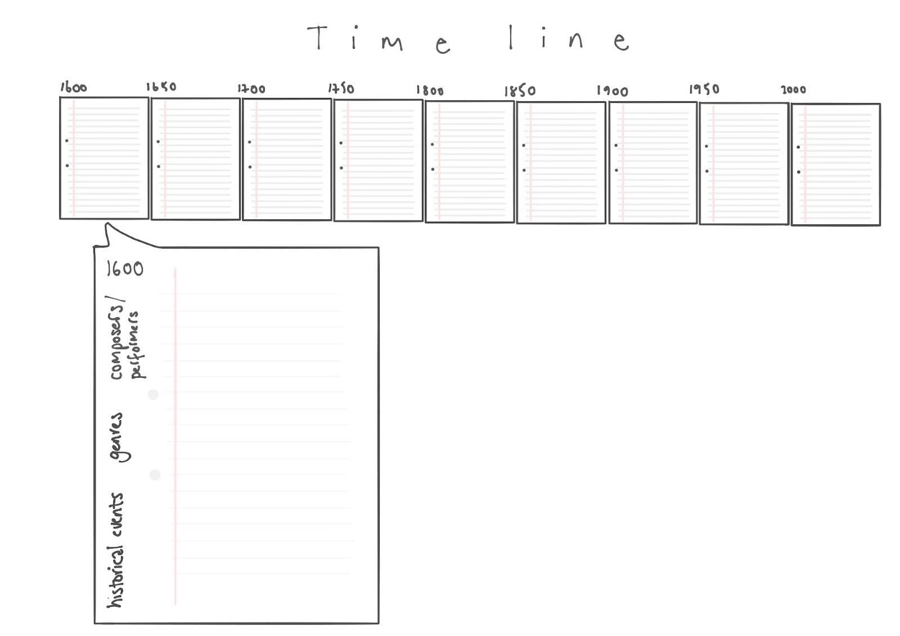
While it’s fine to look at published composer timelines, there’s nothing like assembling your own as you listen to repertoire and get to grips with the provenance of works.
Treat your timeline as a listening diary - something that you can populate over the next 2 years.
These playlists will get you started: https://open.spotify.com/playlist/5Zd2oOOzqELn9ZvOtzGK6U?si=9bf9603ecfc34800
https://open.spotify.com/playlist/0cO3enGXLjOx3Kdmv9EdnC?si=6e83473b85124c63
https://open.spotify.com/playlist/049ta0tFcHRkzn8ckz4rq6?si=d2ba2cdda25448b3
Choose a piece from the playlist to listen to. Research the composer/performer and the genre of the work. Alternate between familiar and unfamiliar names/works.
Task 5:
Start listening to ‘The Listening Service’ on BBC Sounds. You will learn loads.
Tom Service (York University Music graduate btw) has a lovely easy-going manner. He explores some great repertoire and tells some interesting stories behind well-known works and composers. https://www.bbc.co.uk/programmes/b078n25h/episodes/player
Task 6:
Start a chat group with everyone else in your A level Music group. Invite year 13 A level musicians too. Talk to one another. Share your performance work. Share your composition work. Share the research you’ve done, the links you’ve found, your ‘Eureka’ moments.
Go to concerts together, play together, sing together.
Don’t wait for someone else to organise it - you do it.

https://www.aqa.org.uk/subjects/music/a-level/music-7272/specification-at-a-glance

