Summer Reading for IB Philosophy

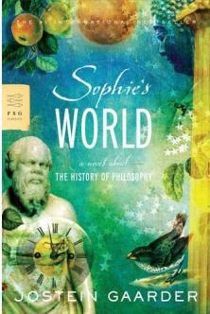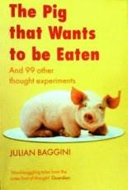
1.

Sophie’s World

by Jostein Gaarder

•

This whole book

is very good, but especially chapter one.

•

Make notes on
the key ideas of at least 10 major philosophers
mentioned in the book.

•

Note down anything that might suggest an
answer to the question
“what is a person?”

2.

The Pig that Wants to be Eaten

by Julian Baggini

•

Pick 5 thought experiments from this book and write down your own
thoughts to the scenario. How would you respond?

•

Some of the thought experiments are available

on
http://thepigthatwantstobeeaten.blogspot.co.uk
/

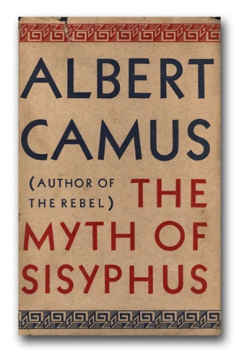
3.

The Myth of Sisyphus
by Albert Camus

•

A classic in the field of existentialism.

•

After reading, summarize Camus’ attitude to the meaning and

purpose of life.

•

http://dbanach.com/sisyphus.htm

If you want to get ahead and think more deeply about the discipline of Philosophy sign up to and complete this OpenLearn course, it is free and you will get a certificate of completion to show your teacher, it requires a bit of a time commitment, but the tasks and activities are very varied and it is an excellent starting point: https://www.open.edu/openlearn/history-the-arts/philosophy/introducing-philosophy/content-section-0?active-tab=description-tab

