Spanish IB Ab Initio Bridging Work
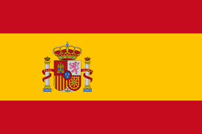
Compulsory tasks | Advisory task
Create your own grammar explanations with examples on the following:  - Present tense  - Near & Simple future  - Preterit & Imperfect  https://studyspanish.com/grammar may help. | Create your own grammar explanations with examples on the following:  - Conditional mood  - Si clauses  Create a bank of the most useful Spanish verbs.
Create a vocabulary list for each of these topics:  - Greetings & common questions  - Describing people  - Food & drink  - School & work  - Holidays  - Hobbies | Research Spanish & Latin American customs in relation to these topics.  Are there any particular differences?  Do they have different sports?  Do they have different foods?  How does their daily life differ to our culture?
Get the app and join Memrise and work through this course. http://www.memrise.com/course/5000726 | Watch a Spanish film or series – What do you learn from it?

