Spanish IB Higher/Standard Bridging Work
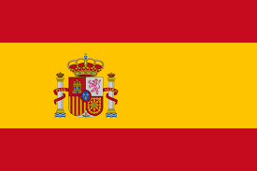
Compulsory tasks | Advisory task
Create your own grammar explanations with examples on the following:  - Present & Present continuous  - Near & Simple future  - Preterit & Imperfect  - Perfect & Pluperfect  - Conditional mood  - Present subjunctive  - Si clauses (3 types)  https://studyspanish.com/grammar may help. | Create your own grammar explanations with examples on the following:  - Imperfect subjunctive  - Passive voice  - Relative pronouns  - Possessives  - Direct & Indirect object pronouns  - Conditional perfect
Watch the film “Ocho Apellidos Vascos” and produce a summary. | Research the film and the cultural differences that feature heavily in the film.
Higher Students - Read the book “Como agua para chocolate” & “Campos de Fresas” and produce chapter summaries. | Research the themes in the novels and the use magical realism.
Find a recent Spanish article which deals with each theme:  - Family and society changes  - Festivals and customs in Latin America  - Gastronomy in Latin America  - The Media & communication  - Immigration  - Environmental issues in Latin AmericaSpan  https://www.practicaespanol.com/ may be helpful. | Gather a bank of statistics related to each of the themes and research how these statistics compare to UK statistics.
Create a template for the following text types you will need to produce in your course:  - E-mail  - Informal letter  - Formal letter  - Interview  - Blog | Also produce templates for the following text types:  - Newspaper article  - Persuasive speech  - Proposal letter

