SCHOOL UNIFORM AND P.E. KIT

Main School Uniform: see visual below
- Navy blazer with school badge*
- Gold blouse with collar, to be worn tucked in with no tie
- Plain white shirt with collar, to be worn tucked in and with a school tie*
- Navy skirt with AES logo* or black/grey trousers (ankle length, tailored and not flared). Denim, cords, lycra and leggings are not acceptable.
- Plain black/navy socks, black/navy tights (not both).
- Year group pin badge to be worn on blazer lapel (through Student Services/ParentPay)

Optional:
- A plain navy V-necked pullover with gold trim and school badge* may be worn, but only under a blazer.
- Optional navy polo shirt with printed school logo – Summer Term Only

Shoes:
- Plain black shoes without commercial logos (see visual on page 37).
- No boots, sandals, trainers, plimsolls or canvas shoes.
- Shoes should be of a safe and sensible style. Shoes should have a low heel. High heels of any sort are not acceptable.
- Black laces.

Jewellery:
- For reasons of safety only limited items of jewellery are permitted. One small stud earring may be worn in the lower lobe of each ear. These must be removed for PE, therefore, any new piercing must be done at the start of the six-week holidays. Parents who wish their child to wear a piece of jewellery for religious reasons must apply to the Headteacher for an exemption.
- No other facial or visible body piercings are allowed; this includes nose and tongue piercings.
- A wristwatch may be worn but no smart watches are permitted to be worn during tests/examinations

Make Up & Accessories:
- Discreet make-up is permitted.
- Hand decoration is not permitted, unless for religious observance.
- Nail varnish or false nails are not permitted.
- False eyelashes are not permitted.

Headwear:
- All accessories must be black or navy.
- There is no restriction on hair colour or style.
- Long or beaded hair must be pulled back for sports and practical subjects.
- No sunglasses

Outdoor Wear Only:
- Plain black or navy coat with minimal logo – needs to be waterproof. No leather or denim.
- Plain dark hats, scarves and gloves
- Hooded tops are not permitted.
- Clothing associated with sports teams (other than AES) are not permitted.

PE KIT supplied by Price and Buckland – See visual below
Essential:
- Royal blue polo shirt with yellow piping and school logo.
- Royal blue skort, or Royal blue shorts with yellow piping and school logo.
- Royal blue socks with yellow top.
- Royal blue reversible Rugby shirt with yellow piping and school logo and/or Royal blue sweatshirt.
- Rugby gum shield.
- Sports training shoes (not plimsolls), no Velcro fastenings.
- Any colour football or rugby boots and football shin pads.
Optional:
- Navy blue tracksuit with yellow piping and school logo.
- Royal blue base layer top.
- Royal blue or black base layer leggings.
Wearing Glasses Whilst Playing Sports:
If your child needs to wear glasses in order to safely participate in PE and be able to see clearly, they are required to wear specialist sports glasses for any contact sports such as football and rugby. You may also wish to consider sports glasses for other ball games such as netball and basketball.

Parents are free to purchase uniform from any supplier if it conforms to the uniform requirements and the colours established by the school’s suppliers:

School Uniform suppliers*
Price and Buckland www.price-buckland.co.uk
PMG Schoolwear www.pmgschoolwear.co.uk

School PE Kit supplier
Price and Buckland www.price-buckland.co.uk

Anglo European School
Student Services also supply year group pin badges, blazer badges, school ties and gum shields.

Nearly new Uniform and PE Kit: Nearly new sales are held at the end of every half term (date will be confirmed in the bulletin). Alternatively, contact the school Office, enquiries@aesessex.co.uk

ALL UNIFORM/P.E. KIT MUST BE CLEARLY MARKED WITH THE OWNER’S NAME
Regrettably, the School cannot take responsibility for loss or damage to property.

Any parents with concerns regarding the Uniform Policy should address them directly to the Headteacher.

Price and Buckland Limited
www.price-buckland.co.uk
Tel: 01159640827 / Email: sales@pricebuckland.co.uk

 | School Uniform for Years 7-11: | Sizes
 | Navy Blazer with school logo | 28” to 36” | £27.95
 |  | 38” to 48” | £33.45
 | School tie to be worn with white | 52” | £9.10
 | button Up shirt/white blouse
 | Open Collar gold blouses twin pack | 24” to 36” | £16.80
 | Long/short sleeves No Tie | 38” to 48” | £19.95
 | White shirts and white blouses available from website, to be worn with a tie
 | Optional navy polo shirt with printed | 28” to 36” | £9.75
 | School logo – SUMMER TERM ONLY | 38” to 48” | £11.65
 |  | Multi buy discount for polo shirts available on line
 | Optional knitted sweater | 28” to 34” | £19.00
 | with gold stripe and logo | 36” to 48” | £22.75
 | Knife pleat skirt with adjustable waist | 22” to 26” | £19.50
 | With school logo | 28” to 40” | £24.00
 | Girls trousers | 22” to 26” | £15.50
 | Three lengths available | 28” to 40” | £18.50
 | Boys Trousers, pleat or flat front | 22” to 26” | £15.50
 |  | 28” to 40” | £18.50

Orders on-line

Sizing guides on our website: https://www.aesessex.co.uk/uniform-list/ or on Price and Buckland
website: www.price-buckland.co.uk
Free delivery to work/home address on all orders over £70.00
Parents can spread payments across 3 months through Klarna
Free returns
To ensure delivery for the start of September term, we strongly advise that you place your orders
by the 31st July 2025

Price and Buckland Limited
www.price-buckland.co.uk
Tel: 01159640827 / Email: sales@pricebuckland.co.uk

PE kit for Years 7-11:

Essential | Size | Price
Royal blue polo shirt with yellow piping and school logo | Size 28”-S  Size M-XXL | £13.75  £16.25
Royal blue skort  Or  Royal blue shorts with yellow piping and school logo | 22-26”  28”-36”  9-13 years  S, M, L | £13.75  £16.45  £9.75  £11.75
Royal blue reversible rugby shirt with yellow piping and school logo  and/or  Royal blue ¼ zip sweatshirt with yellow piping and school logo | 30-32”, XS, S  M, L, XL, XXL  and/or  30”, 32”, XS  Size S-XXL | £18.00  £21.50  and/or  £16.75  £20.25
Royal blue socks with yellow top | Size 3-6  Size 7-11, 12-14 | £6.50  £8.00
Optional | Size | Price
Navy blue tracksuit top with yellow piping and school logo | Size 9/10 - 13  S-XXL | £19.00  £23.00
Navy blue tracksuit bottoms with yellow piping | 9-13 years  S-XXL | £14.50  £17.50
Royal blue base layer top | 28”-XL youth  XS-XL | £14.50  £15.50
Black base layer leggings | 22” to XL Yth  S-XXL | £17.50  £21.50

Orders on-line

Sizing guides on our website: https://www.aesessex.co.uk/uniform-list/ or on Price and Buckland website: www.price-buckland.co.uk
Free delivery to work/home address on all orders over £70.00
Parents can spread payments across 3 months through Klarna.
Free returns
To ensure delivery for the start of September term, we strongly advise that you place your orders by the 31st July 2025


Website: www.pmgschoolwear.co.uk  Telephone: 01895 809321  School Uniform for Years 7-11: |  |  |  | Sizes
Navy Blazer | 28” to 30” | £39.99
Badge on pocket | 32” to 34” | £42.99
 | 36” to 38” | £44.99
 | 40” to 44” | £48.99
 | 46” to 52” | £52.99
Navy pleated skirt | 22”/18” to 24”/20” | £27.99
Badged top left | 26”/18” to 28”/20” | £29.99
 | 30”/18” to 32”/20” | £32.99
 | 32”/22” to 38”/22” | £34.99
Gold L/S Blouses twin pack | 28” to 34” | £18.99
 | 36” to 40” | £19.99
 | 42” to 46” | £23.99
Gold S/S Blouses twin pack | 28” to 34” | £18.99
 | 36” to 40” | £19.99
 | 42” to 46” | £23.99

Sizing guides are available on PMG website: https://pmgschoolwear.co.uk/
 | To ensure delivery for the start of September term, we strongly advise that you place your orders by the 31st July 2025

SCHOOL UNIFORM

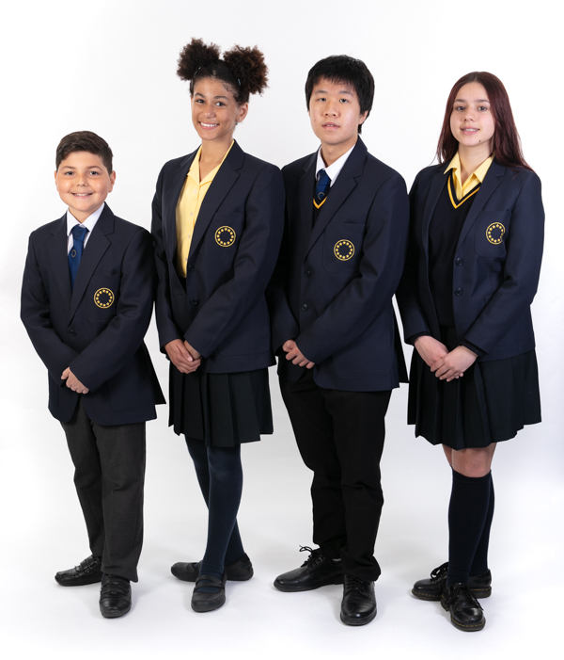

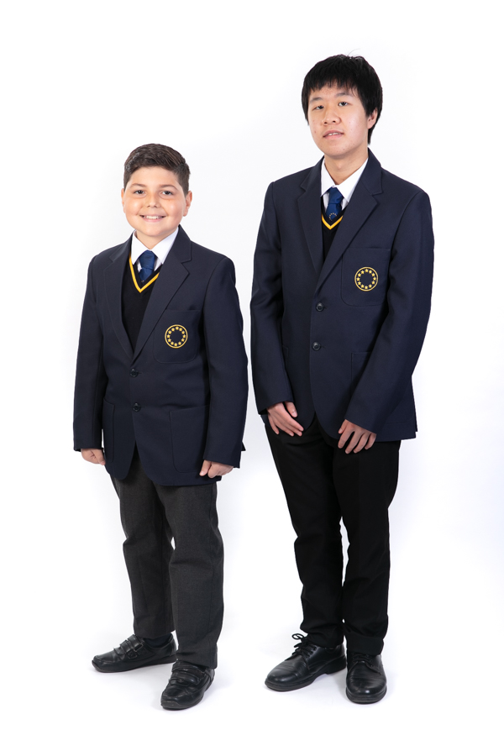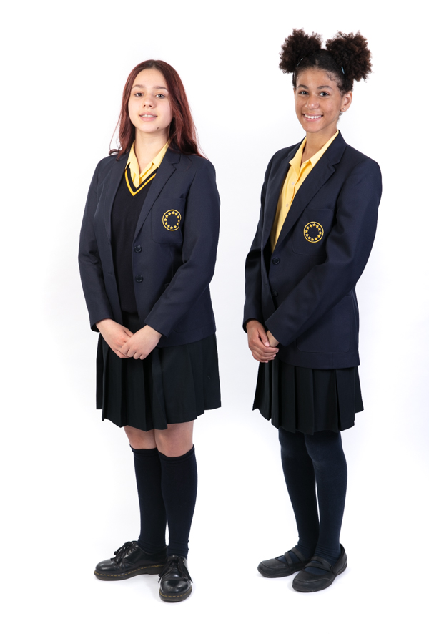
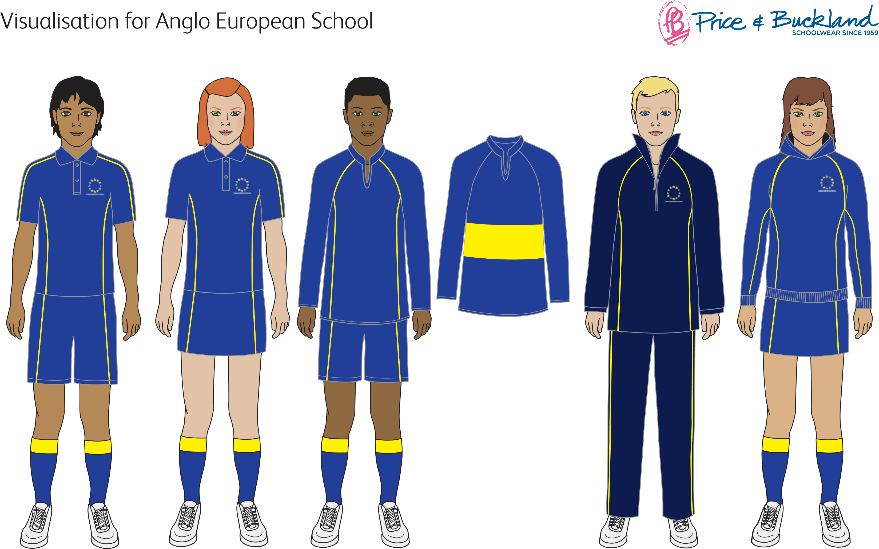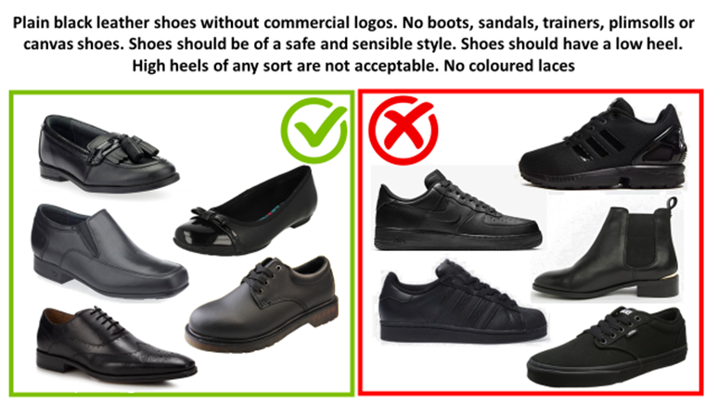
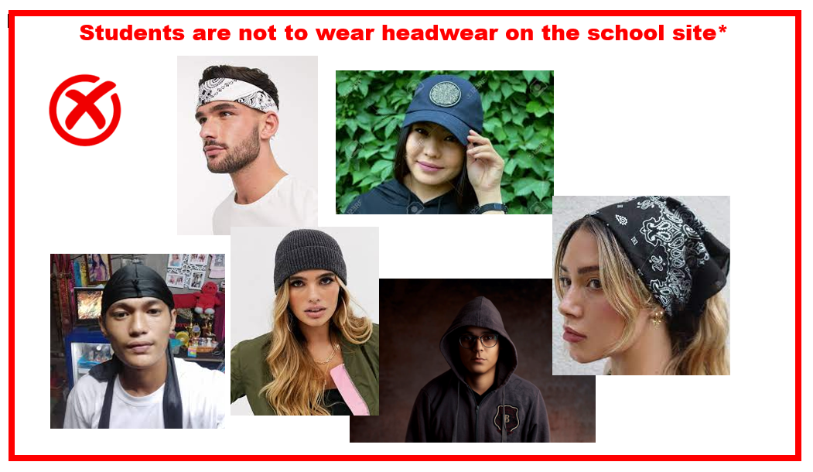

*Unless permission is received from the Headteacher for religious or cultural reasons

