
IB Standard Japanese Lower 6th

Curriculum Intent
The Japanese department seeks to develop ambitious and resilient linguists who recognise their common humanity and strive to gain inter-cultural understanding and respect.
We aim to provide an understanding of Japanese in a range of themes from social changes, global issues and history which enables students to communicate effectively in authentic situations on their exchange visits and prepared for the challenges of developing the language at a higher level and with an aspiration to continue the language at University or to at least see its value in their future career paths. We intend develop our students to be inquisitive and curious about culture, knowledgeable and understanding, open-minded and courageous as they personally develop through their learning of Japanese.

新しい言語は、新たな人生の始まり。- A new language, a new life. Proverb.

Students will learn:-

The course has 5 prescribed themes:
Identities
- Lifestyles
- Healthy & well-bring
- Language & identity
Experiences
- Leisure activities
- Holidays & travel
- Life stories
Human ingenuity
- Entertainment
- Communication & media
Social organization
- Social relationships
- Community
- Social engagement
- Education
Sharing the planet
- The environment
- Ethics
- Urban & rural environment

Knowledge, understanding & Skills

- To build on the range and complexity of the language they use and understand in order to communicate.
- To understand and evaluate a wide variety of written and spoken authentic personal, professional and mass media texts of increasing difficulty.
- To speak and write, and with a purpose, in order to meet a wide range of communicative needs: describing, narrating, comparing, explaining, persuading, justifying, evaluating.
- To be able to initiate, maintain and close oral exchanges, displaying ability to adapt styles.
- To use a variety of strategies to maintain the flow of conversations and discussions on a variety of topics.
- To develop knowledge of advanced vocabulary and grammar, as well as conceptual understanding of how language works.
- To develop understanding of the relationship between the language and culture
- To develop deeper thinking through TOK Questions.

How can you enhance your learning at home?
- Memrise
- Flipped learning
- Genki Textbook
- Kanji Book Vol 1.
- Essay bank and sample assessments
- William Tweed Resources Library
- PADLET

What does excellence look like?
- Extensive knowledge of vocabulary
- Confident use of Target Language
- Critical analysis of issues/themes/cultural or social contexts demonstrated through convincing interpretations and points of view, consistently justified with appropriately selected evidence
- Detailed, logical arguments and conclusions that consistently link
- Consistent variation of grammatical structures, including in use of complex language, producing consistently articulate writing
- Consistently varied use of vocabulary, allowing ideas to be conveyed in a variety of different ways
- Appropriate use of text formats and style.
- Accurate language throughout resulting in consistently coherent writing and speech
- Any errors do not hinder clarity of communication



How will we assess impact?

Our teaching encourages regular learning of key vocabulary and refinement of grammatical structures that are tested regularly. Vocabulary recall is developed via weekly 10-point tests. Teachers assess pupils less formally in class via the four skills of listening, reading, speaking and writing. Pupils work collaboratively in pairs and groups to constantly improve their speaking skills, providing peer feedback.

Each half-term pupils take an assessment in test conditions during lesson time. In June of the Lower Sixth pupils take a full-length IB-style examination, which helps to predict their final grade as accurately as possible and to offer the students an opportunity to experience the speed and attention to detail required in the examination.

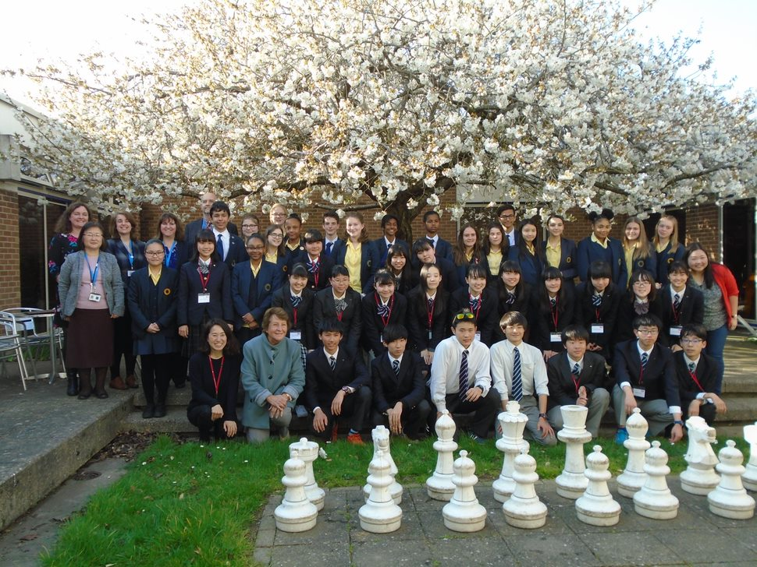
Visits Programmes

- Unfortunately, we don’t currently offer a Japanese exchange in the Sixth Form.

- University visits or cultural day visits may be arranged.

Within the curriculum

- The IB curriculum is designed to deepen understanding and appreciation of Japanese culture and customs.

- Students are encouraged to research each theme beyond lessons and set work to ensure that they can draw on a wide knowledge of the culture and society.



Wider Reading

Introduction to Japanese culture – Daniel Sosnoski

Japanese stories for language learners – Anne McNulty & Eriko et al.

Matriculation
GCSE Grade 5 or higher

言語を知ることは、賢者への道。
Proverb
Knowledge of languages is the doorway to wisdom.

