TUESDAY LUNCH MENU
MAINS
Meatballs in tomato sauce £2.20
Macaroni cheese £1.55
Spaghetti 75p
Sweetcorn free with any meal 40p
Garlic bread 55p

VEGETARIAN
Plain pasta 75p
Pasta with tomato & basil sauce £1.50
Pasta bake £1.55
Baked 40p
Jacket potato & beans £1.25
Jacket potato, beans & cheese deal £1.70
DESSERT
Syrup sponge 95p
Custard 30p
0p
ERT
Ice smoothie 65p
Jelly 60p
ERT
Hot S/F/Chicken wrap
£3.25

Hot meal deal
MEATBALLS & SPAGHETTI
OR
MACARONI CHEESE & GARLIC BREAD
SWEETCORN
DESSERT or PIECE OF FRUIT
£2.50

PIZZAS
Margherita £1.20
BBQ jackfruit pizza £1.90

Sauce Sachet 15p
Mayo Sachet 20p
Butter Portion 20p
Jam Portion 25p
Cheese quiche £1.45

Bread rolls 65p

FRUIT
From 65p
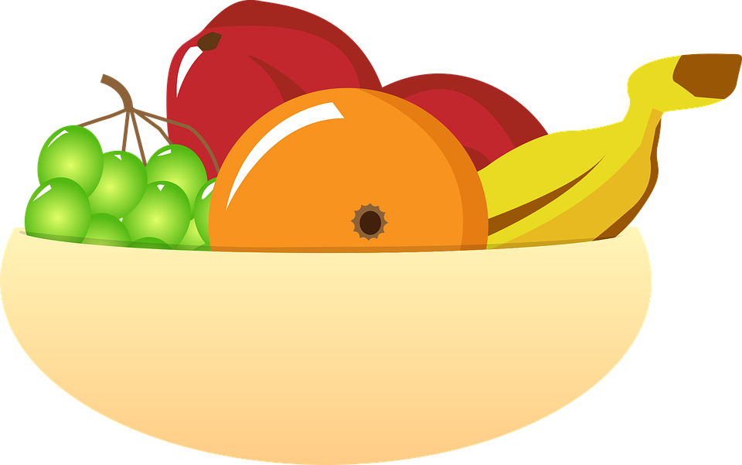
COOKIES & CAKES
Chocolate cookie 65p Iced sprinkle cake 85p
Iced bun £1.25
Plain / chocolate muffin 85p
COLD DRINKS
A selection of flavoured drinks from 85p
Large water 80p Small water 65p
Milkshakes £1.85

If you have a food allergy/intolerance please speak to a member of our staff regarding the ingredients in your meal

