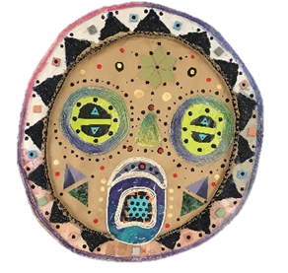
English Literature
International Baccalaureate Upper Sixth
Curriculum Intent

Students will build on their developing ability to create independent interpretations of a variety of literary texts from a wide range of places, genres and periods.

Students will continue to explore the interrelations between texts and the connections between texts and the contexts in which they are written, received and understood.

“You are your best thing” Toni Morrison “Beloved”

How is homework used to enhance learning?

Students should conduct independent research on different ideas of love in:
• Elizabethan era
• The early 20th century
• Scott Fitzgerald
• An film adaptation of Othello

Students should also read:
• Beloved by Toni Morrison;
• Oranges Are Not the Only Fruit, Jeanette Winterson;
• Revolutionary Road, Richard Yates
• Birthday Letters, Ted Hughes

How will we assess impact?
Fortnightly written response with teacher feedback

Critical reading; Analysis and essay writing skills;

Create own exam questions; set question for peers;

Half-termly group presentation

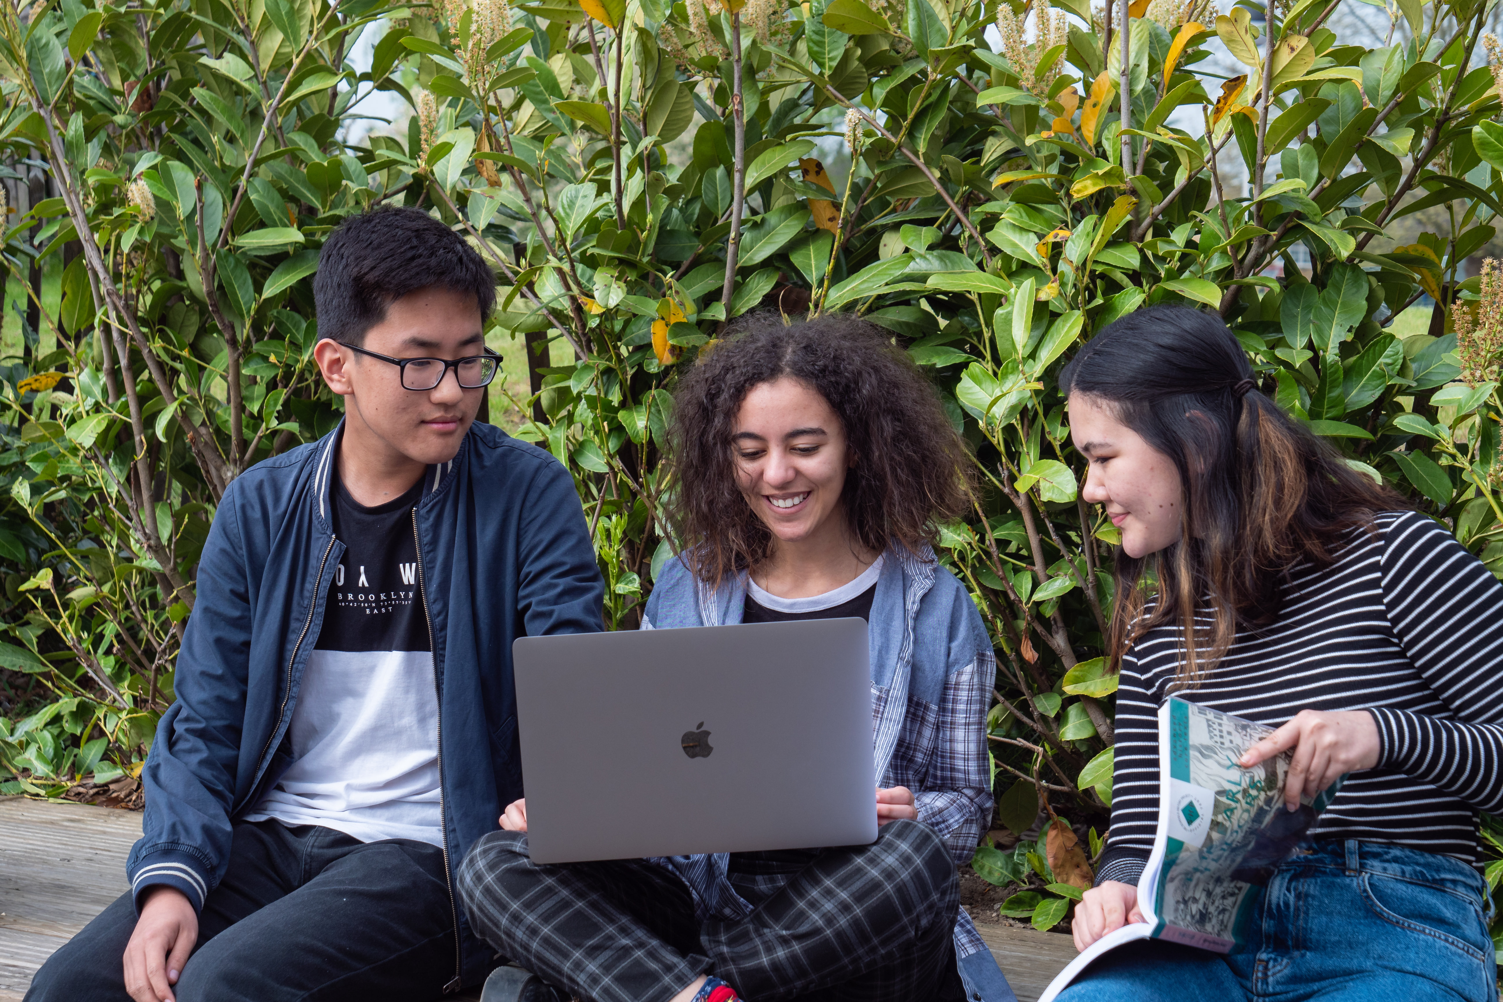
Knowledge, understanding & skills

Students should be able to independently engage critically with a substantial body of texts. In this sense students should be able to:
• Analyse and respond to literary texts. Identifying key themes, understanding how language is used to create meaning
• Conduct independent research and incorporate scholarly opinion into their own ideas.
• Make independent connections between historical contexts and the text being studied.

What does excellence look like?

Students are able to present a unique response to a text and use literary concepts or terminology to express their ideas. This would include:
• Understanding a wide range of different interpretations
• Being able to incorporate different interpretations into their own writing.
• Have an ability to include reference to historical and literary contexts which is both common and subtle
An ability to compare texts looking at how words and phrases shape meaning.

Students will learn:-
Students study to themes: Love through the ages and Literature in Modern Times.

In Love through the ages, students study of three texts: Poetry, Love through the Ages pre 1900 Anthology and The Great Gatsby, and Othello.

Students will begin and complete their coursework which is a comparative essay on two texts. One text is pre 1900 and the other is a text of their choice. It cannot be text currently being studied.

International opportunities within the curriculum

- Ensuring teachers teach at least three works which have been translated into English
- Ensuring teachers teach works which are from three different countries and two different continents.
- Some of the writers and texts covered are: Pablo Neruda, Marjane Satrapi, Primo Levi, John Agard and Murakami Haruki.

